* **1. What is Jenkins | Continuous Integration & Installation process in Windows**

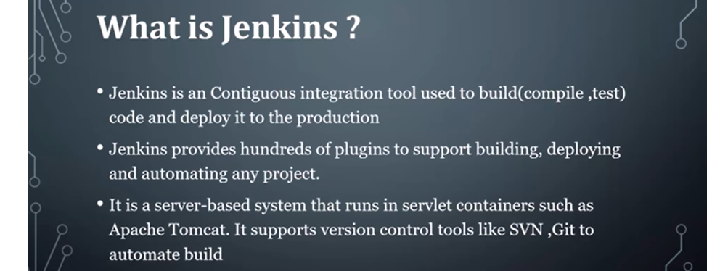

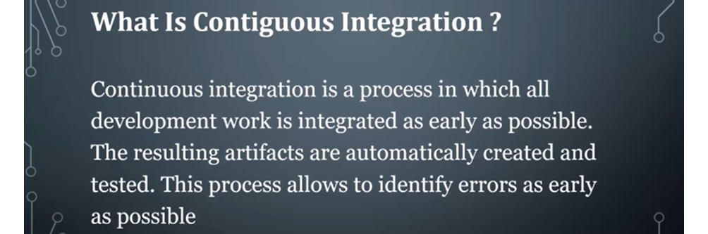

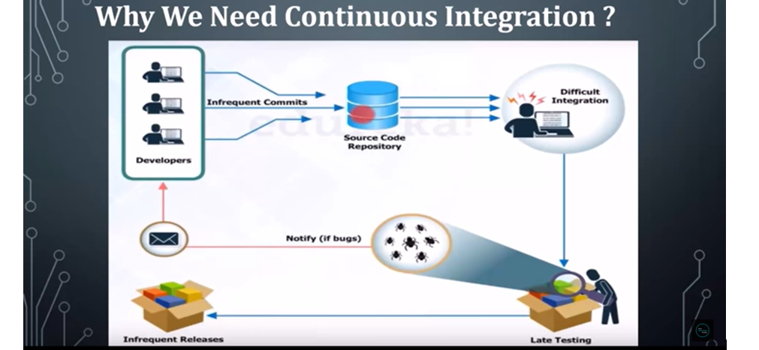

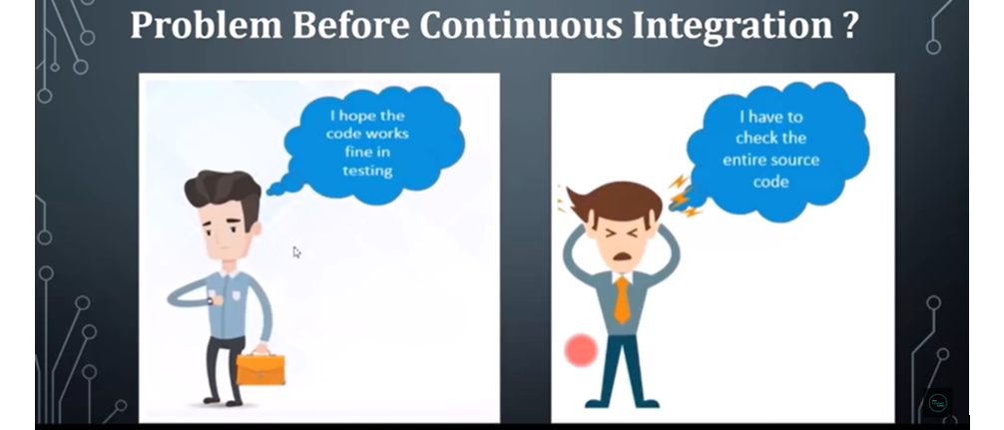

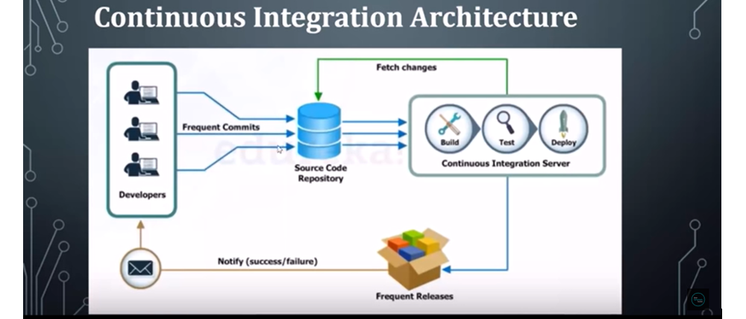

So here you can see for the developer no need to wait for the test result, so at the time of build only if we get any error developer can get the error details.

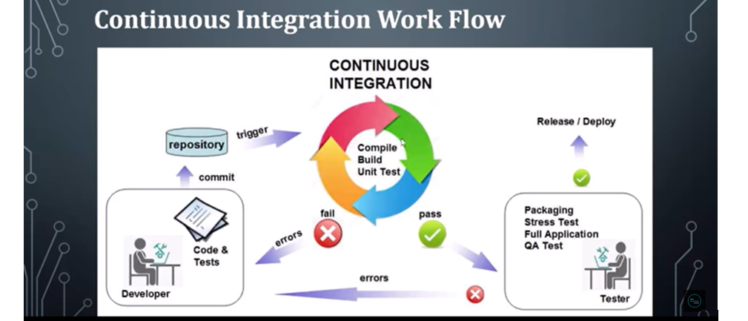

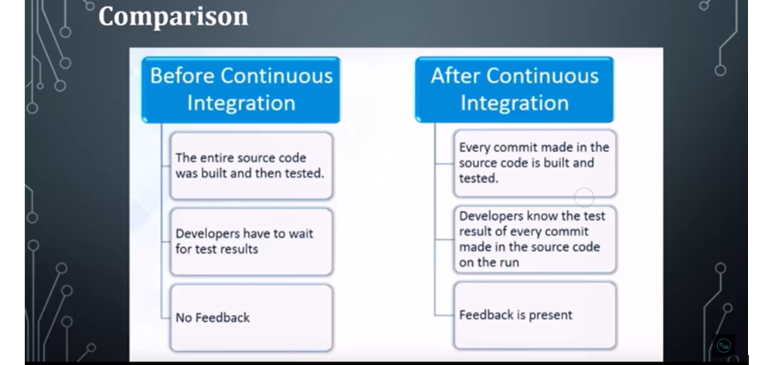

**Let’s Install Jenkins in our Machines:-**

[**https://www.jenkins.io/doc/book/installing/windows/**](https://www.jenkins.io/doc/book/installing/windows/)

**or another way download war file and run…otw first one is run installer…**

**Download the Jenkins war file and start**

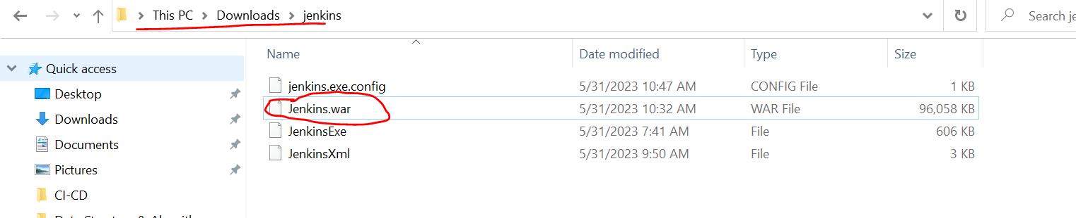

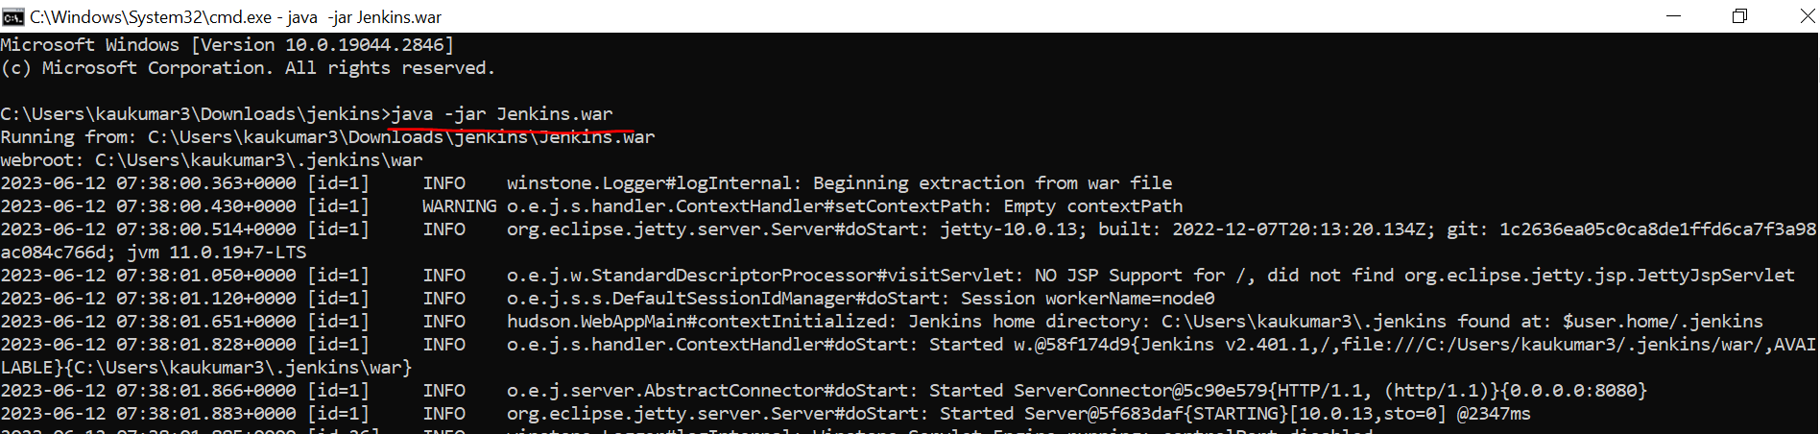

**>> java -jar Jenkins.war**

**Jenkins by default runs on port 8080**

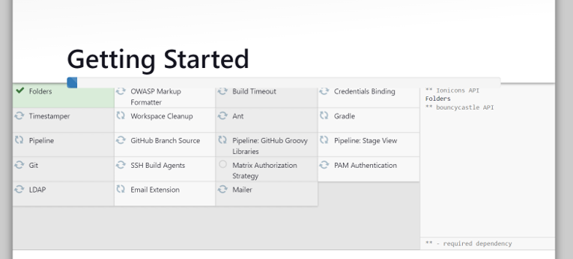

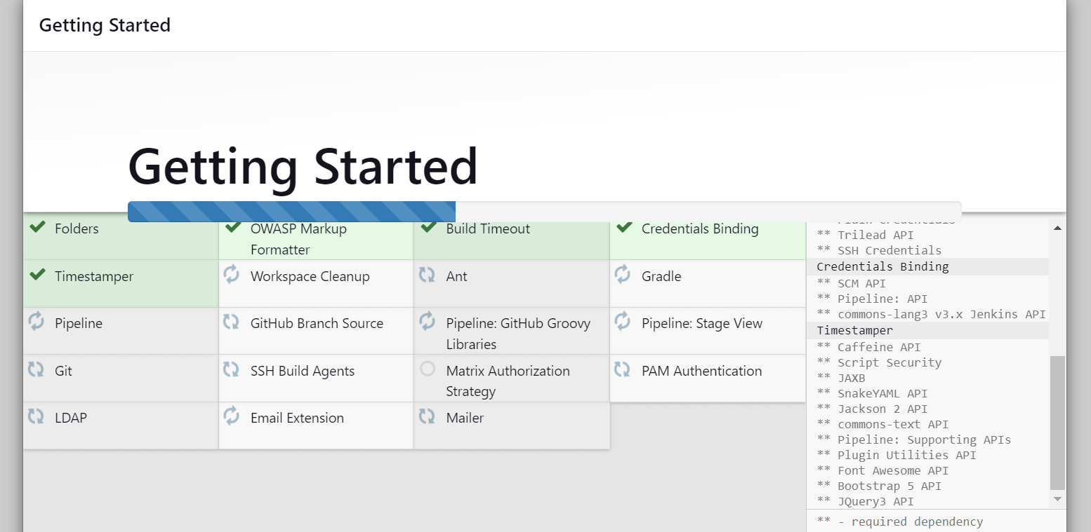

[**http://localhost:8080/**](http://localhost:8080/)

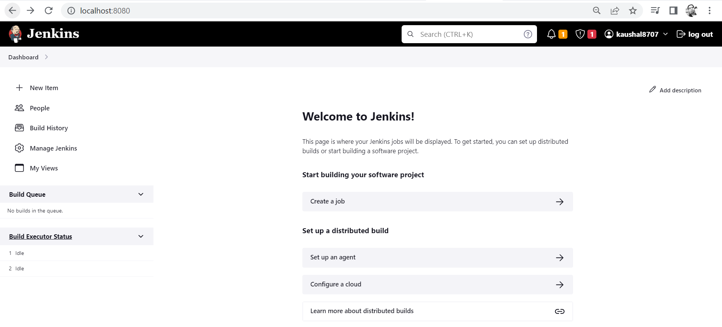

* **2. Jenkins | continuous integration with GitHub & Enable Notification**

Let’s see how we can integrate our Continuous Integration tool i.e Jenkins with our GitHub.

Let’s first create a project in Eclipse/STS.

* Let’s first create a project with name spring-Jenkins
* Create a Git repository with name spring-Jenkins
* Commit your code to this Git repository.

*** Now we have written few lines of codes and added logger as well …and now we have written a test class to identifies either our test process is automated or not with the help of Jenkins.

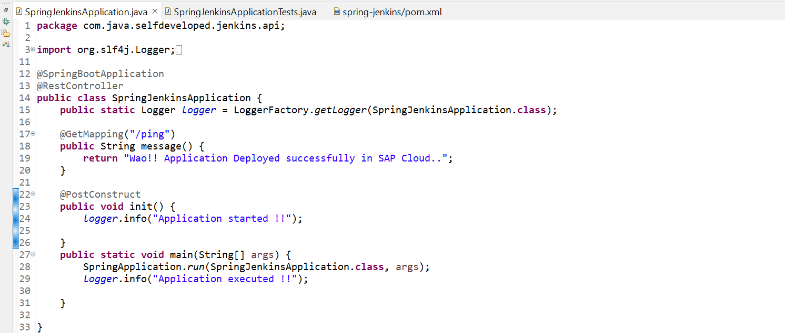

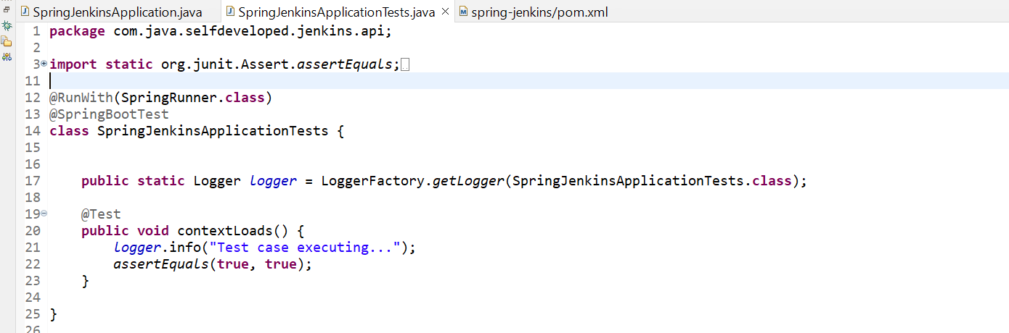

*** We have created one repository and now let’s sink up our code with that repository.

*** Now go to project workspace and open Git bash here and run below commands…

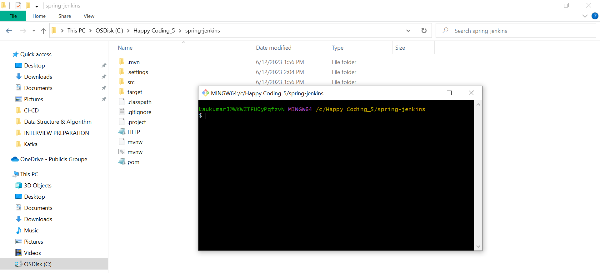

* git init
* git status
* git add *
* git commit -m "first commit"
* git branch -M main
* git remote add origin https://github.com/kaushal8707/spring-jenkins.git
* git push -u origin main

now we can see our project in Git hub.

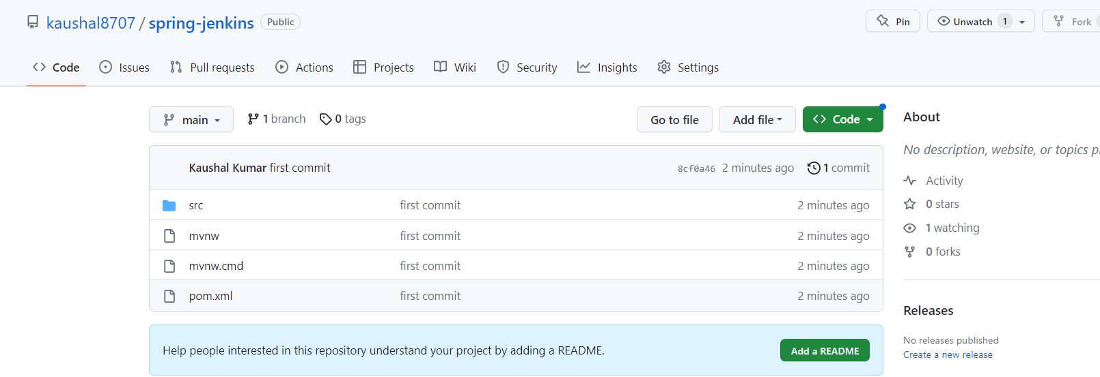

Now come to Jenkins dashboard.

To come to Jenkins dashboard, you need to run Jenkins.war and then hit <http://localhost:8080/>

Let’s create a new **Job**.

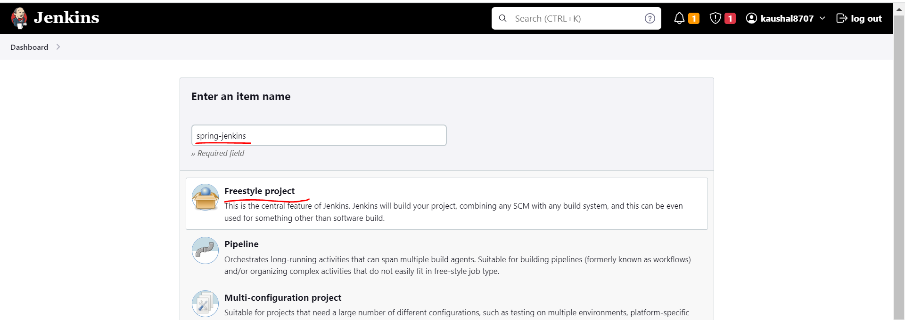

We have selected freestyle project even we can select maven project also we have an option.

Since we are going to sink up Jenkins with our git base project so select GitHub project and provide GitHub url.

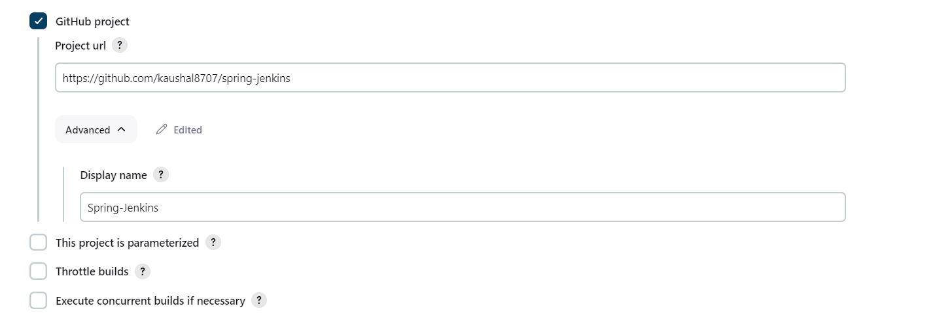

------------------------------------------------------------------------------------------------------------------------------------------

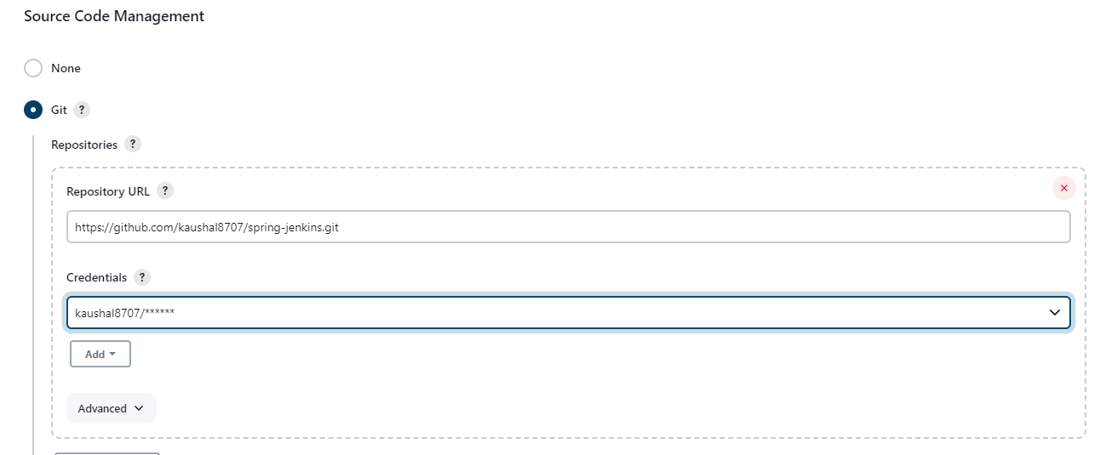

**** Then we can schedule our task, or we can schedule our build.

Suppose in every time change in our this **spring-jenkins** repository I want to be a new build. So, you can schedule your task. Now we can give cron expression like at every minute or at every hour whatever the changes will be done to your repository it will automatically pick and it will do the build with the help of Continuous Integration server. As a temporary basis we are giving * * * * * but this is not the standard.

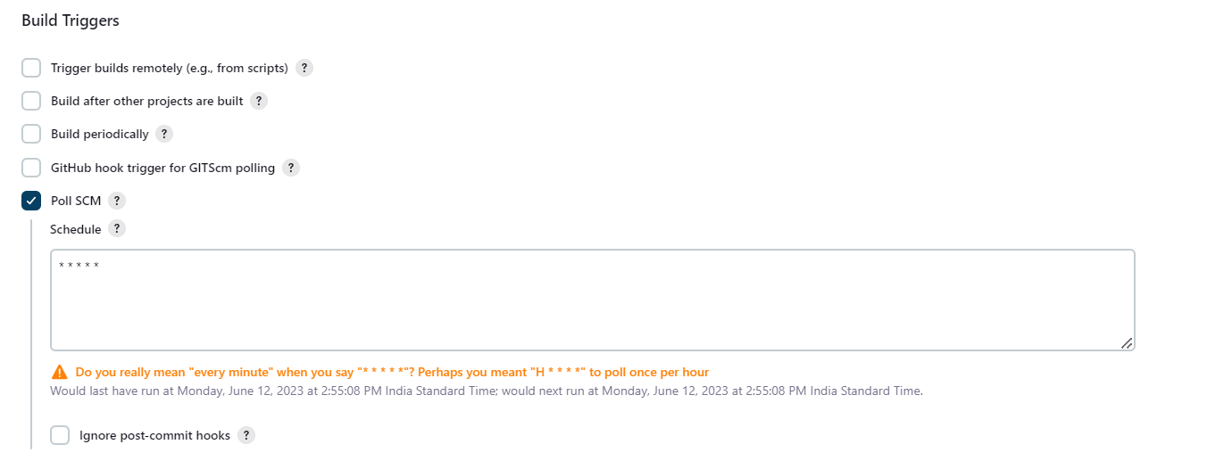

In Build step select **Invoke top-level Maven targets**

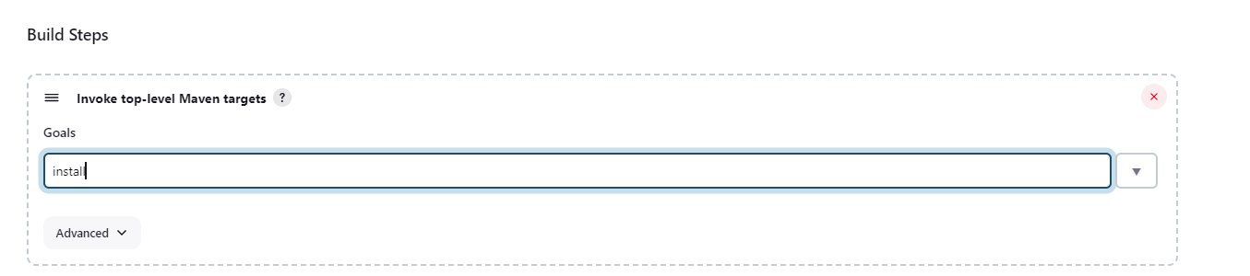

Saved it now go to our jenkins.

Go to Manage jenkins -> Tools

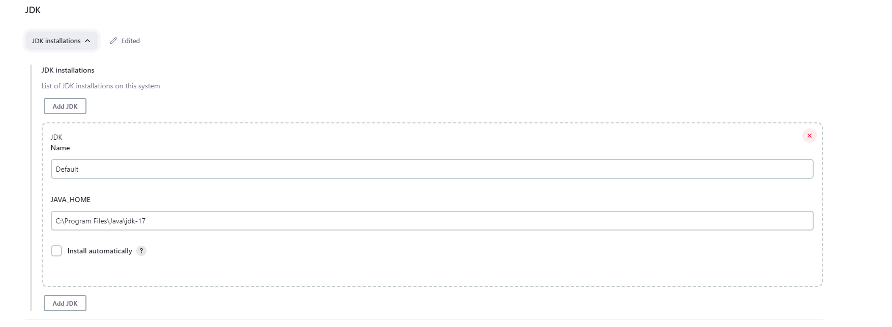

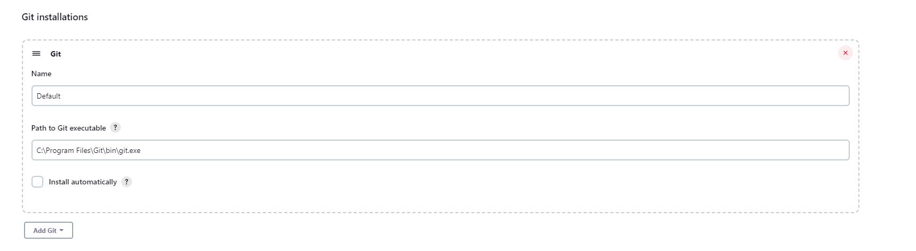

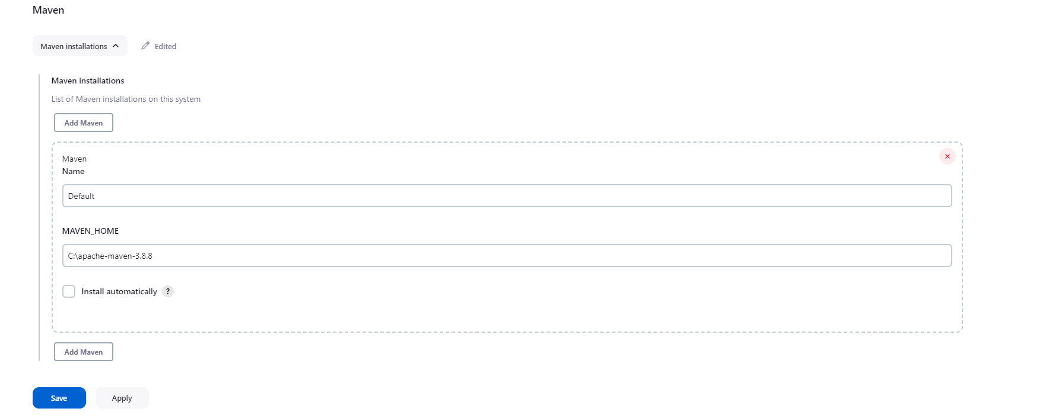

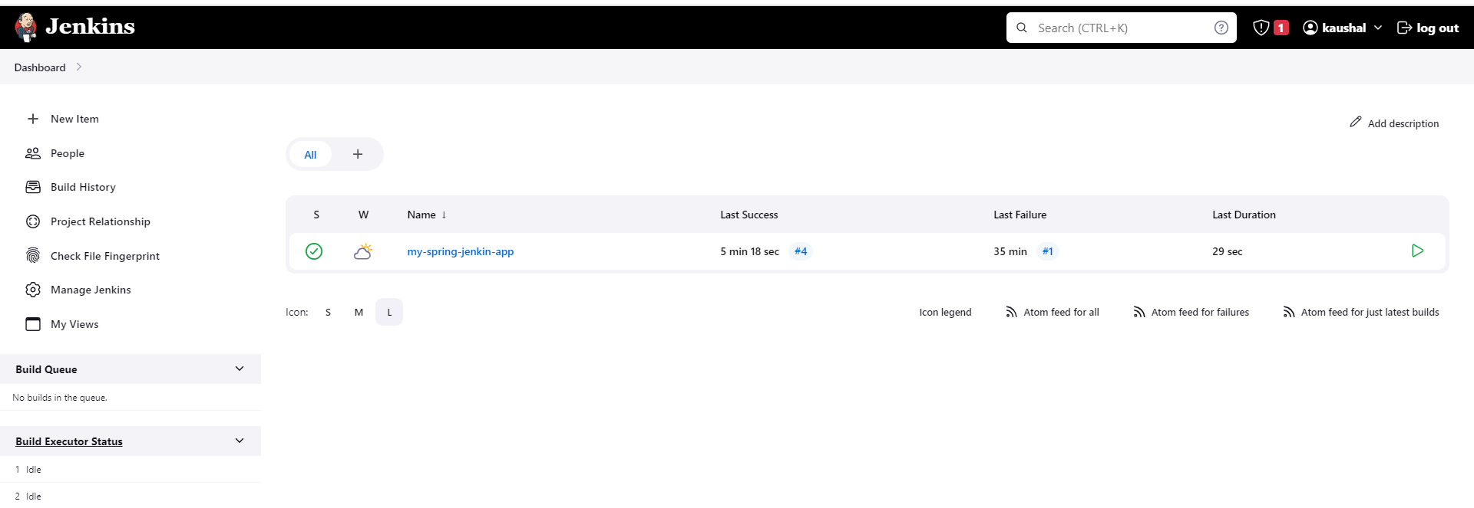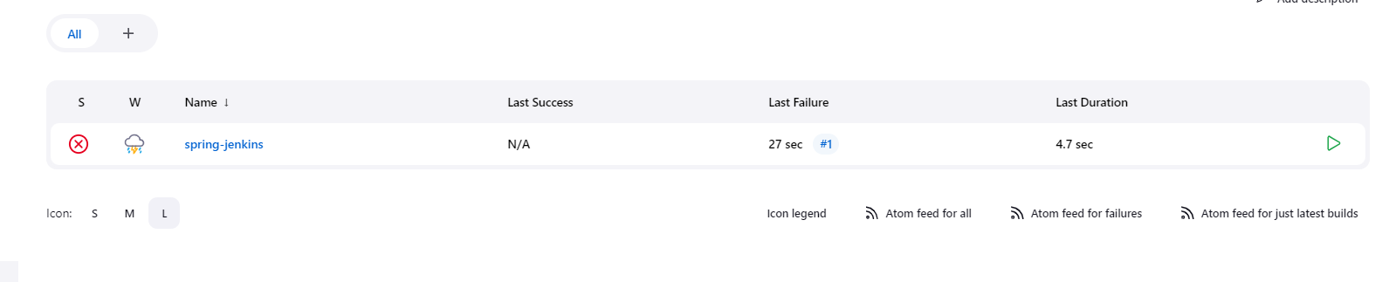

Click on our project

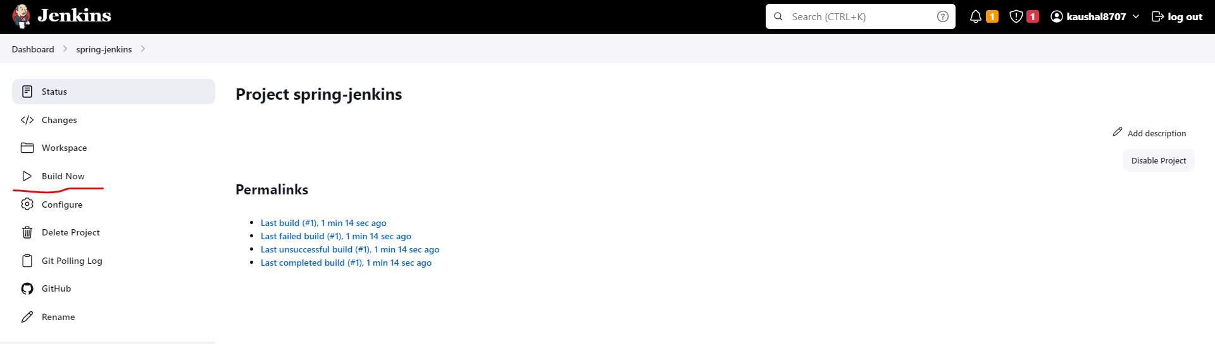

Click build now.

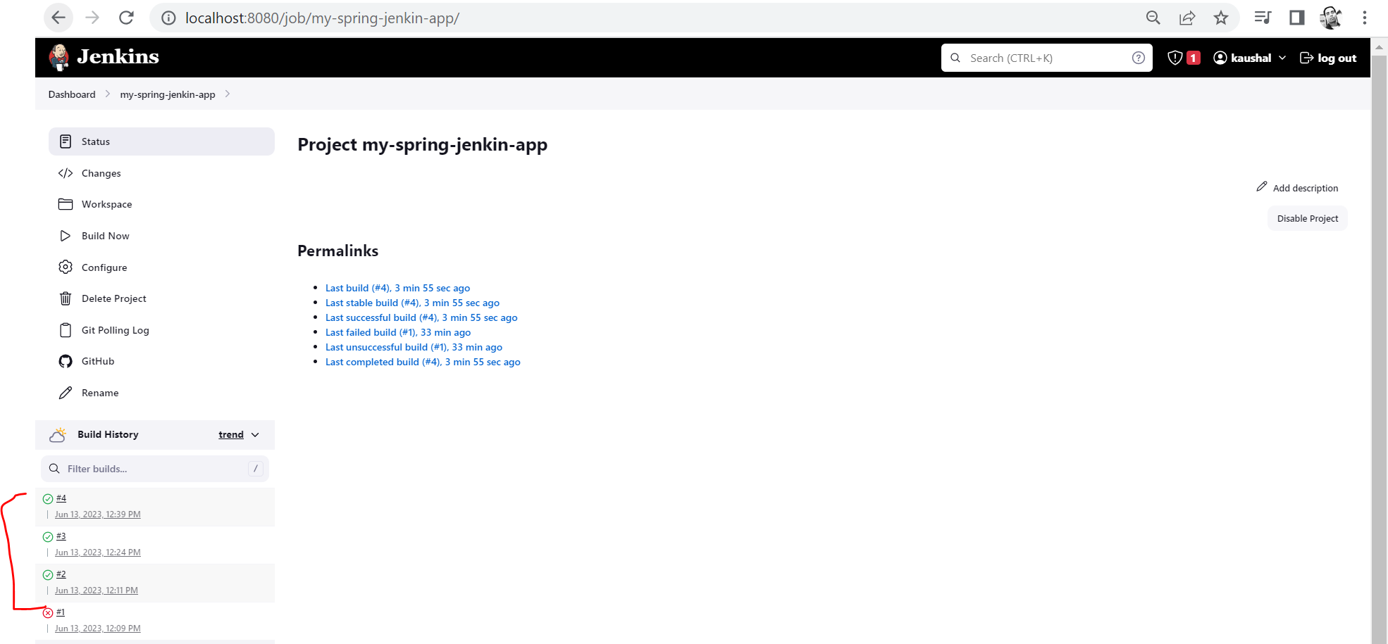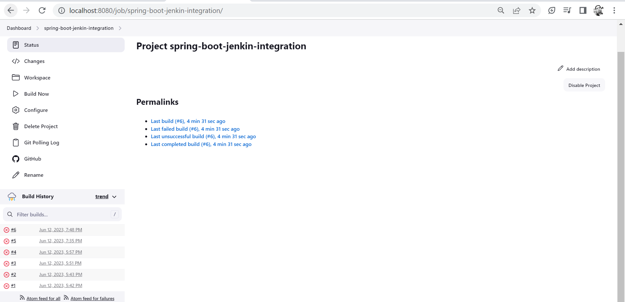

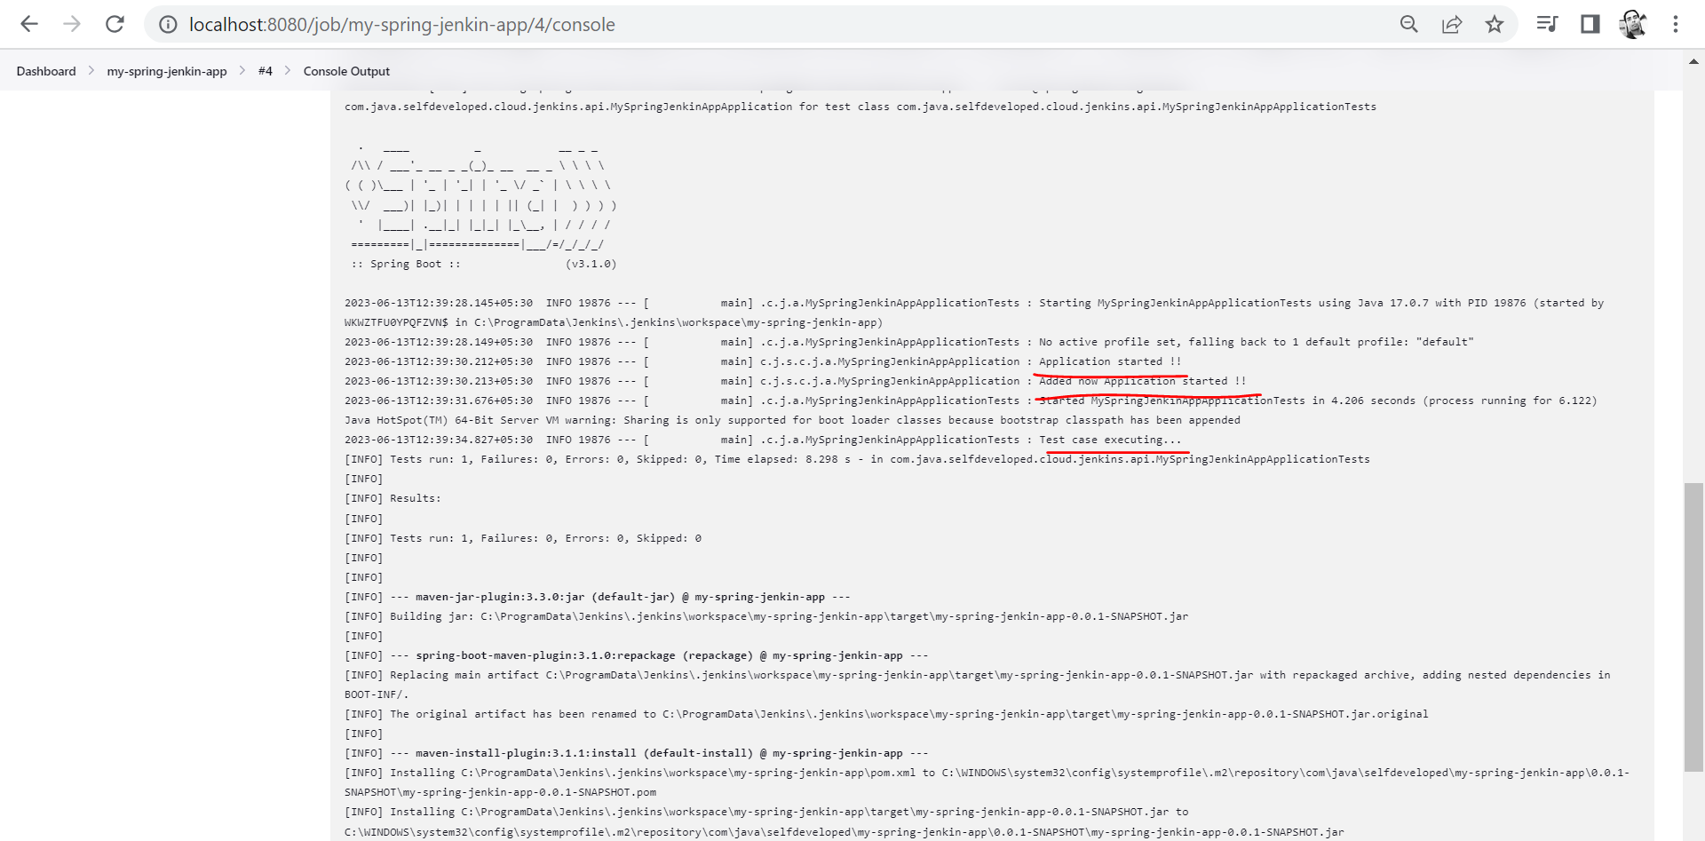

To check the build details message, click on output console.

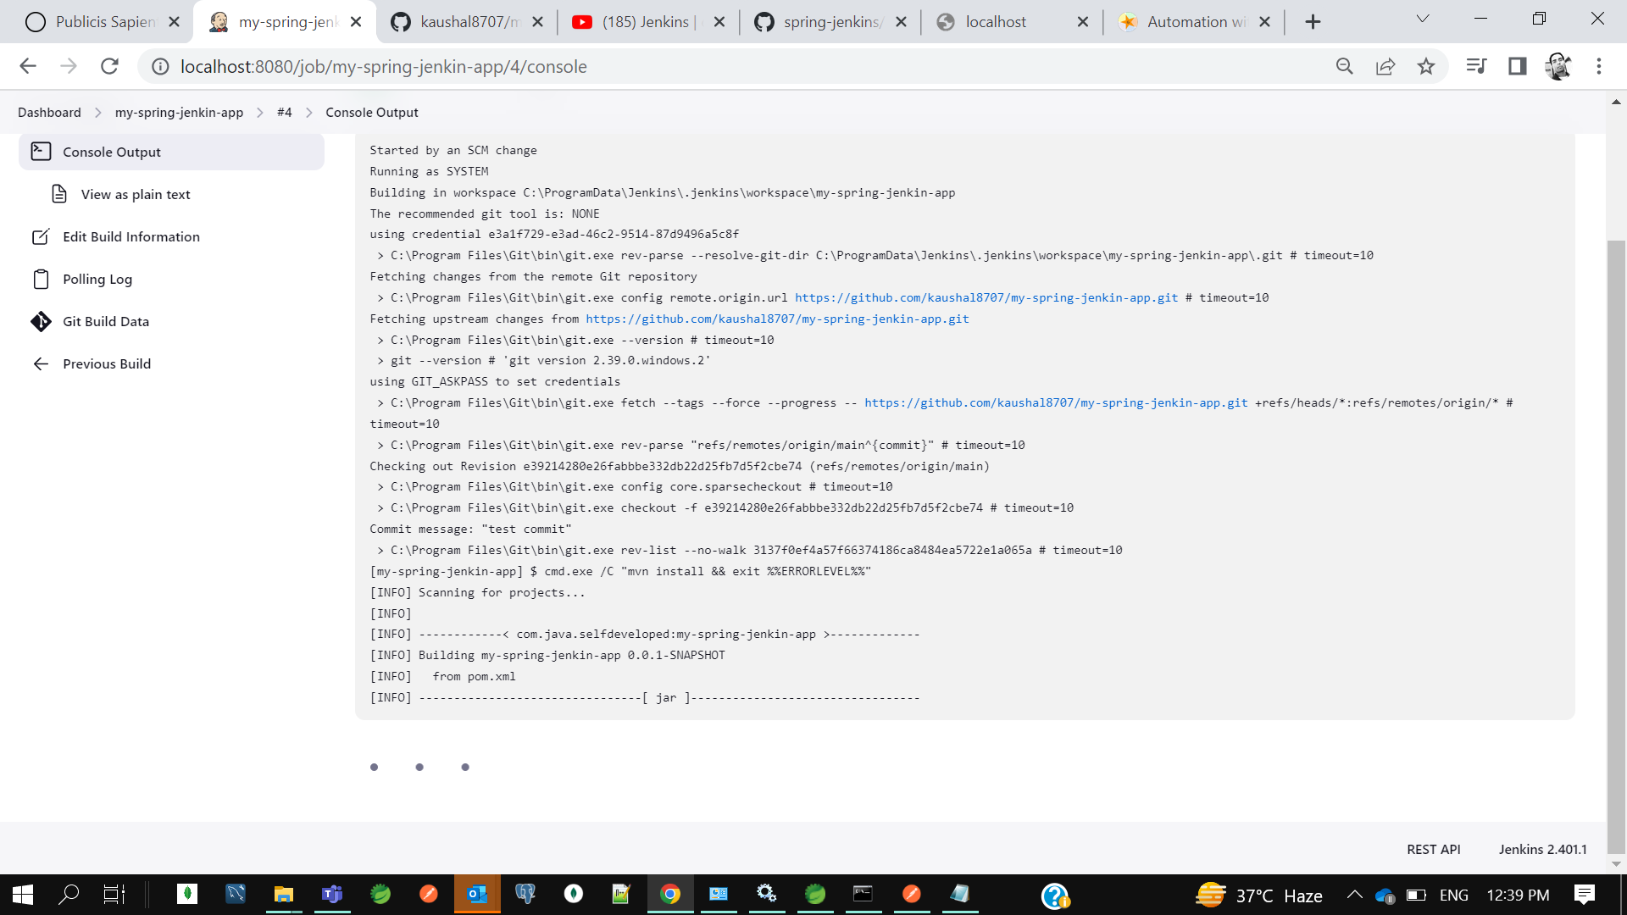

So, this is how to integrate GitHub to Continuous Integration tool Jenkins and how we can automate the build.

So we can see our Build also created and it’s executed Testcase also.

**3. Jenkins - Continuous Delivery pipeline (Dev-Uat-Prod) using Build Plugin Pipeline**

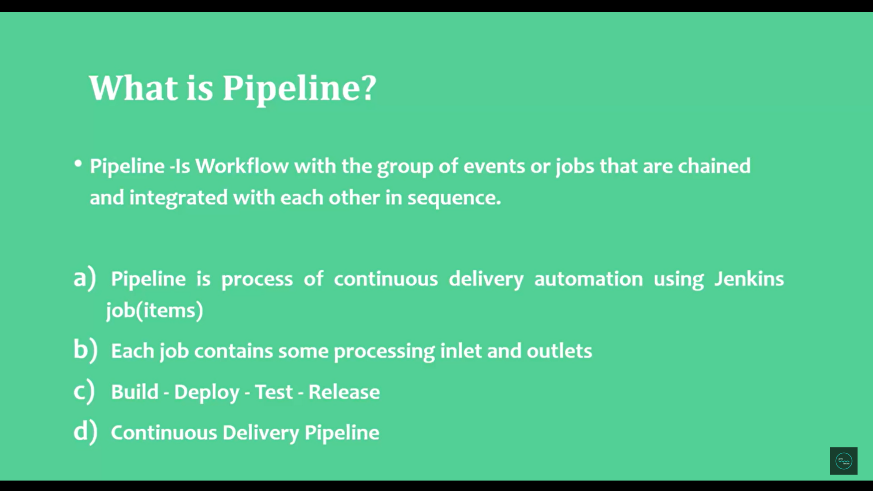

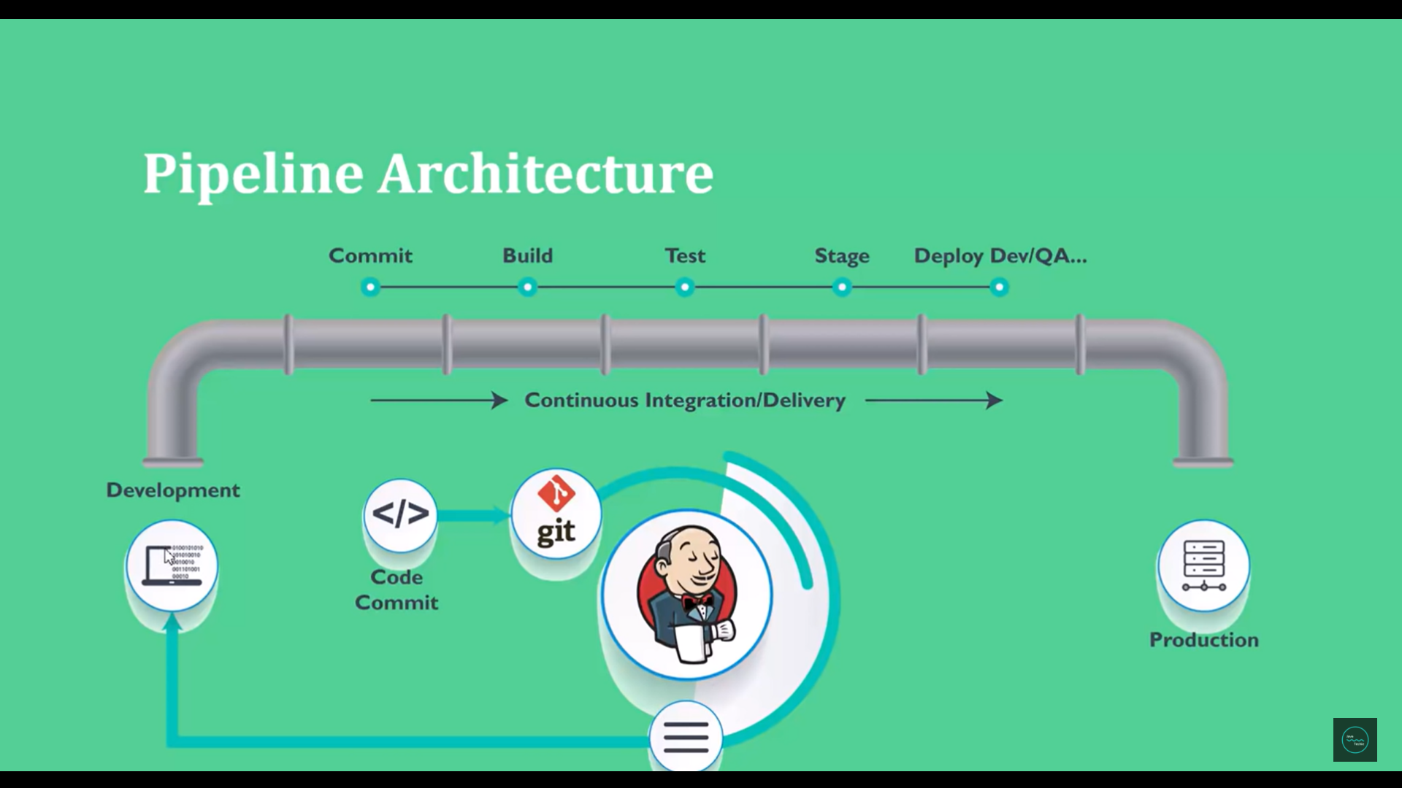

The advantages of use this pipeline assume in this build segment my job getting failed then it won’t move to the next event or next job that is Test. Suppose our test getting failed then it won’t proceed next job. So this is the way we can make our code ready to the production.

So there is a multiple way you can create pipeline

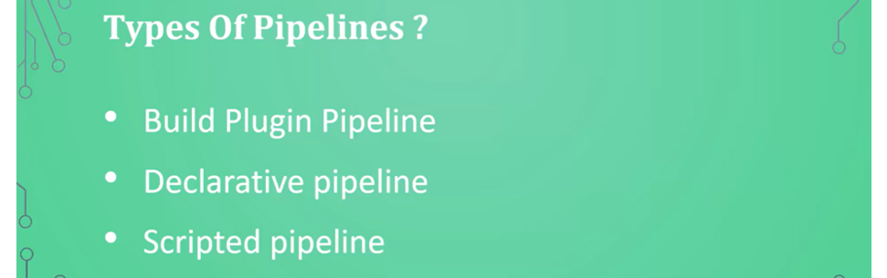

In this session we are going to use Build Plugin Pipeline. We can go for Build Plugin pipeline if our application has less job to execute , less job in the sense suppose I say I want to do the development then the UAT test then the deployment, then I can choose this build plugin pipeline.

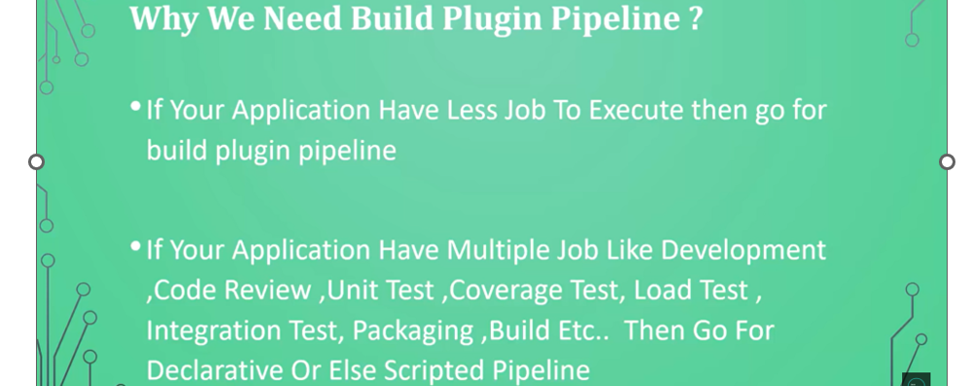

In case of declarative pipeline approach, we need to write jenkins file as part of our code and we can commit it to the git, and we can reuse it. In case of scripted pipeline in jenkins configure section, we need to add those scripts and those scripts is written in groovy syntax.

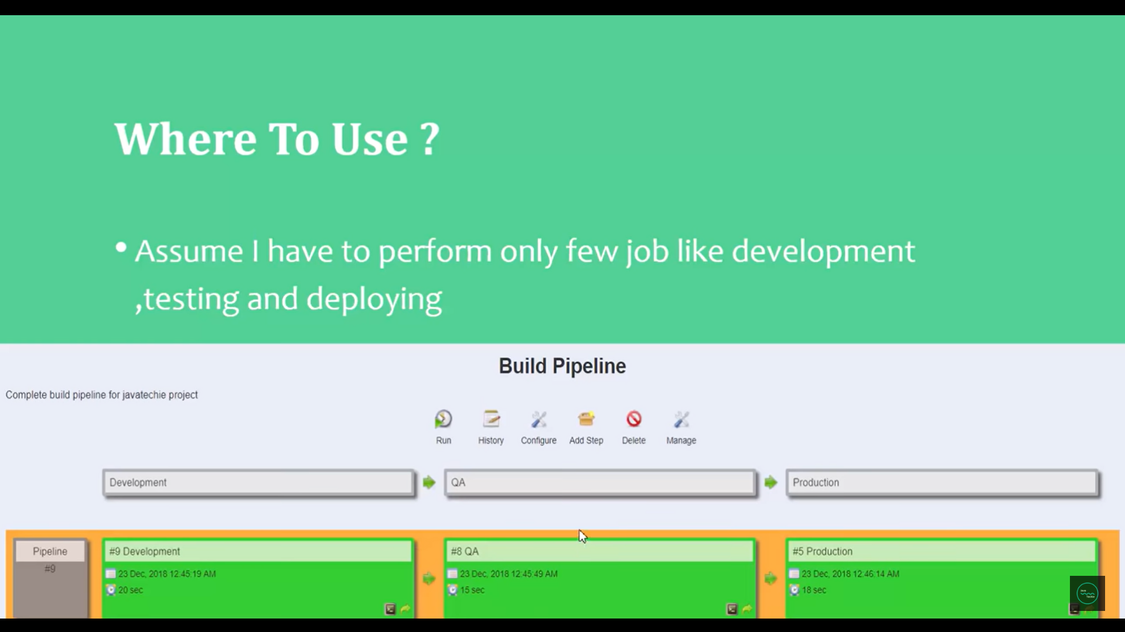

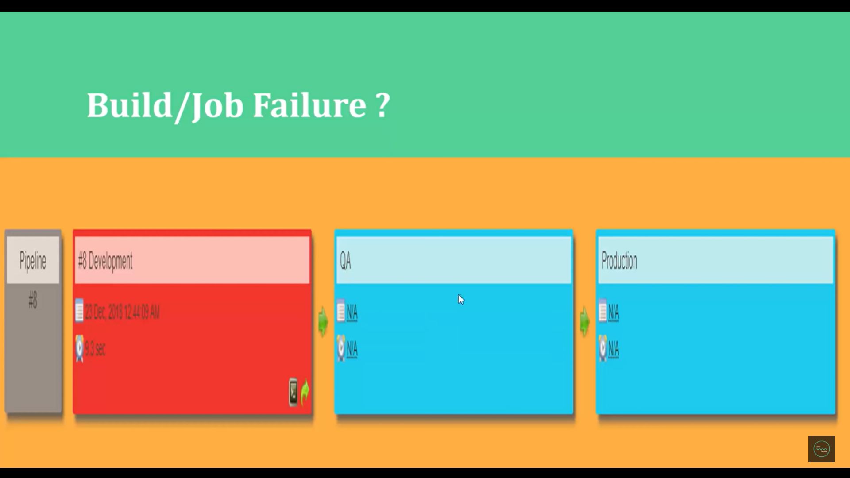

If my development is getting failed, then my build will not trigger for the next job like QA and production. So red and green me if my job will fail in dev env then it won’t move for the next env QA and prod.

Go and run Jenkins.war file or open jenkins which will run on port 8080.

<http://localhost:8080/>

create a new job Dev

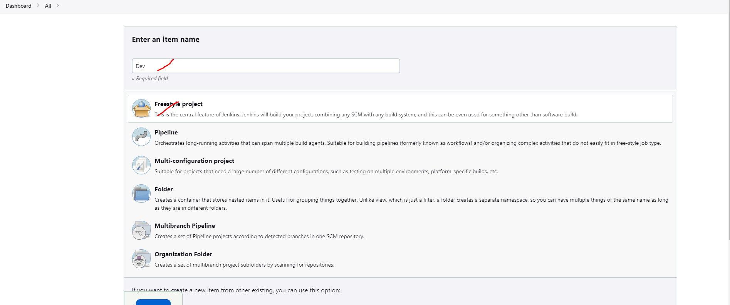

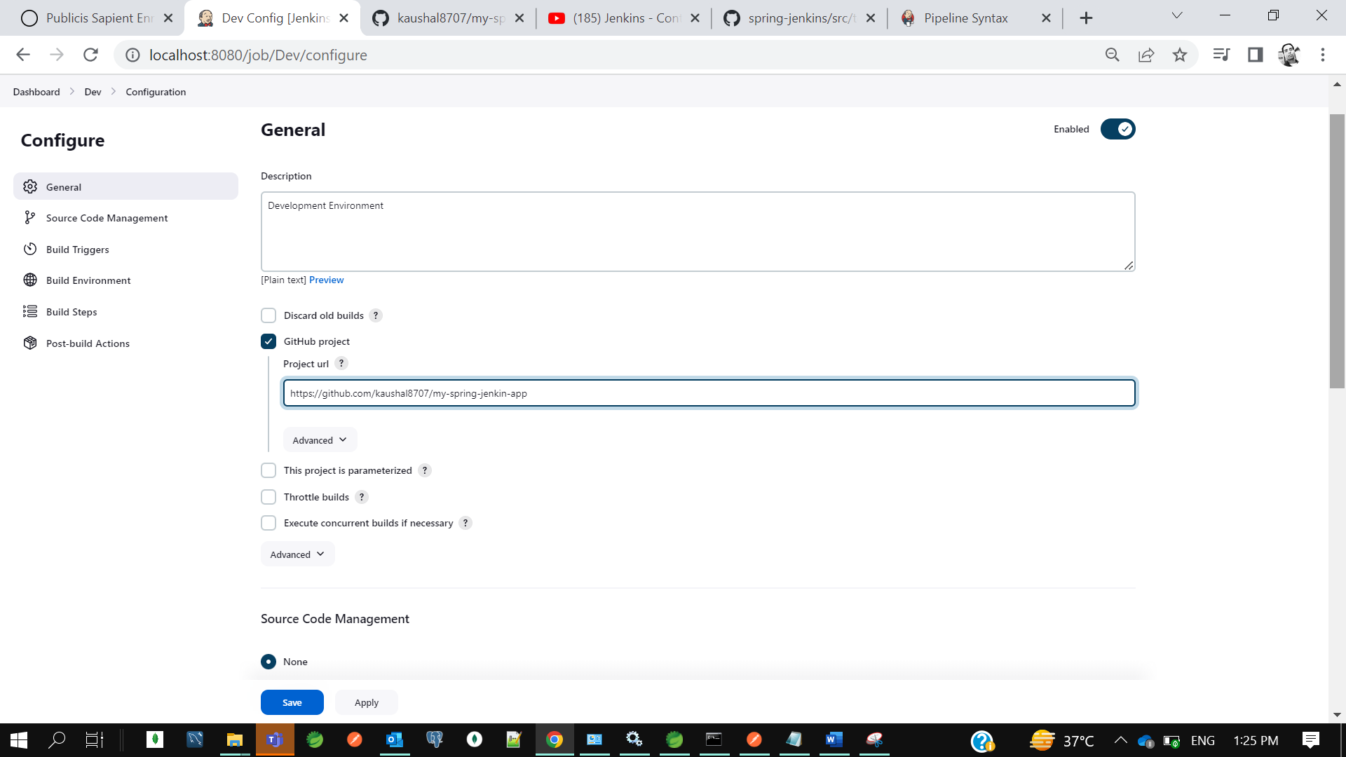

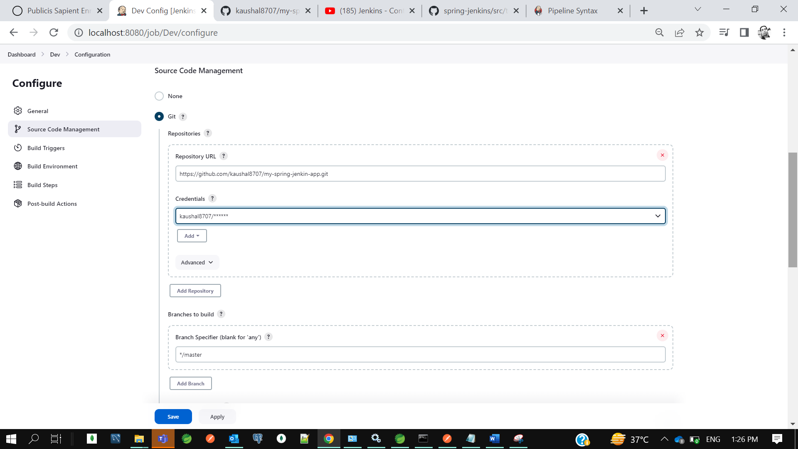

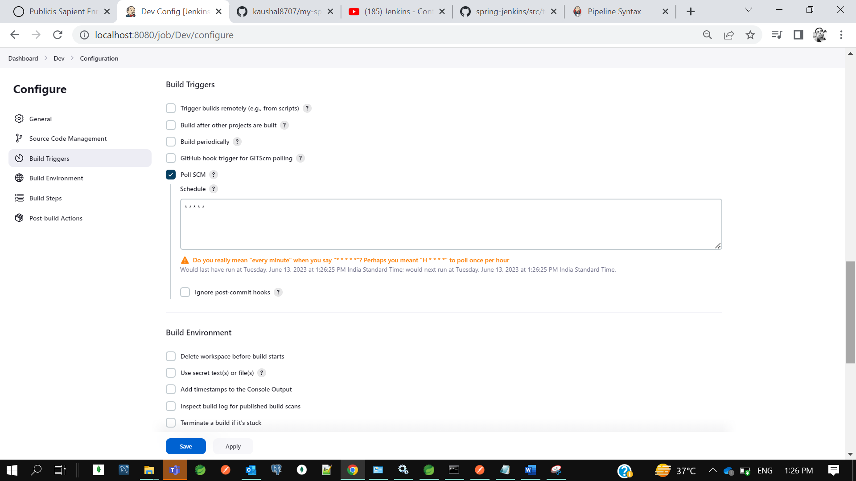

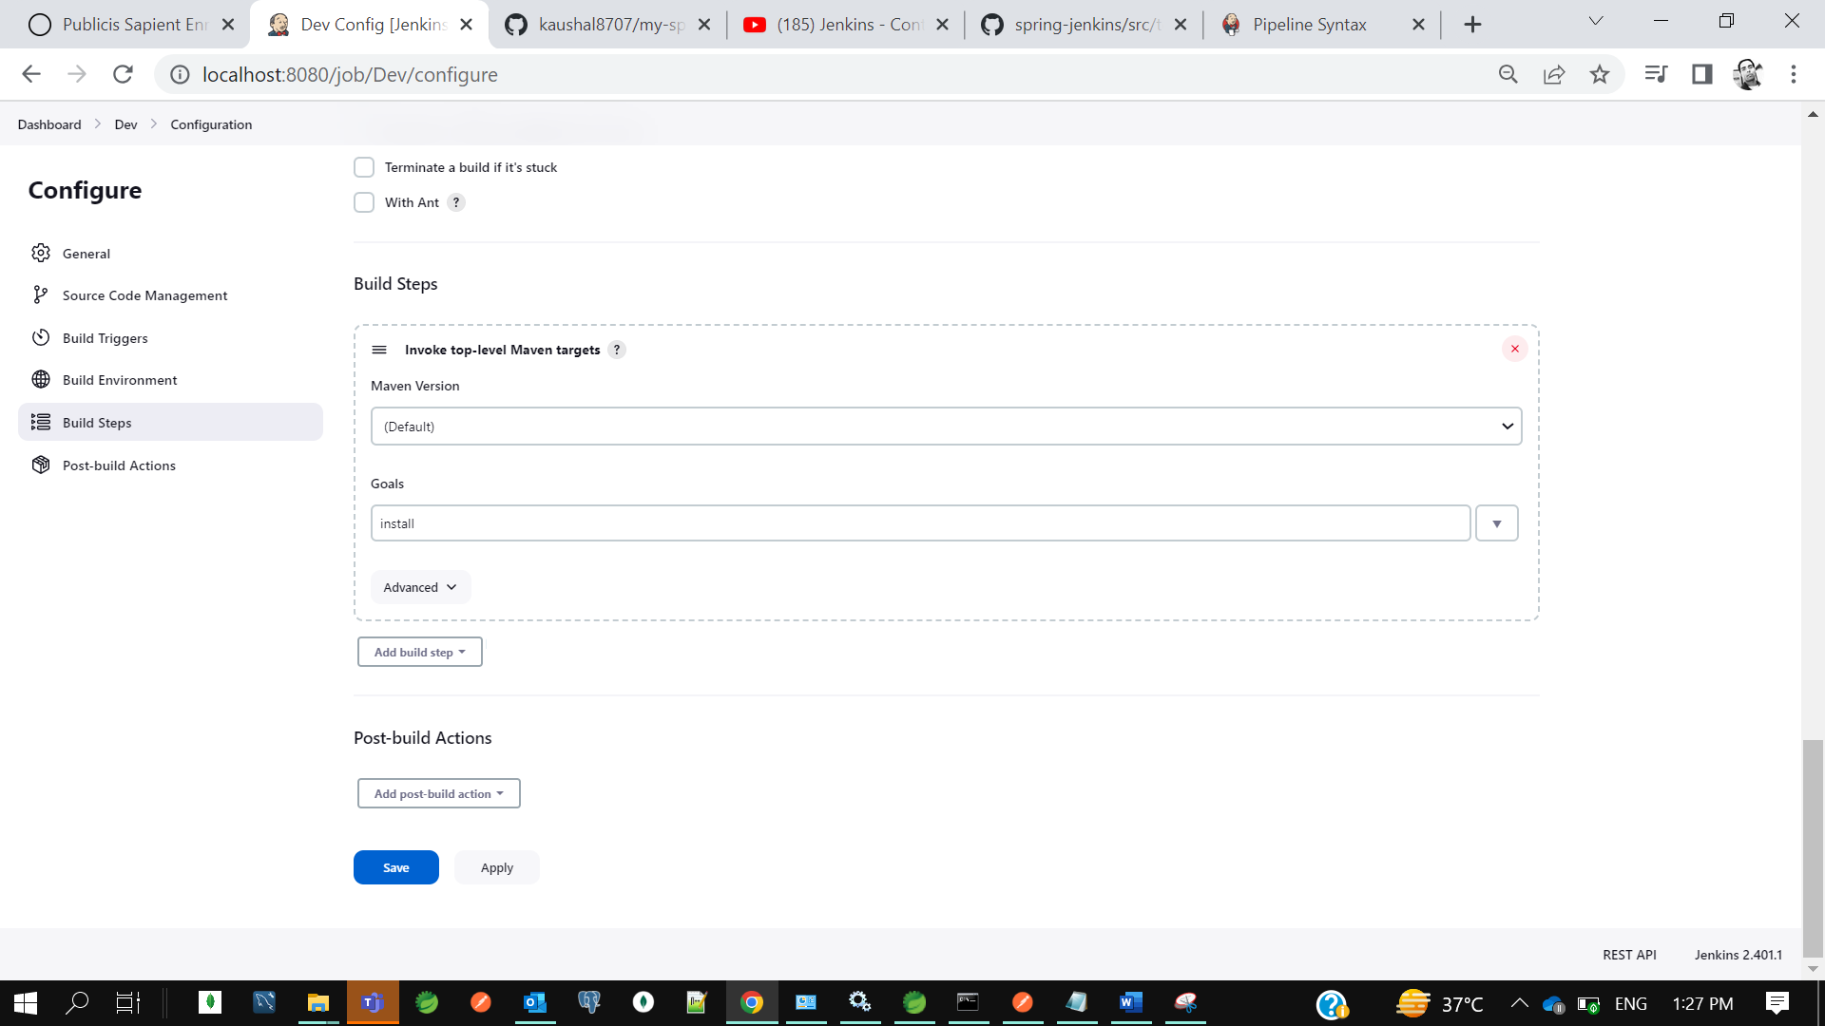

**Similarly let’s create 2 more new job for UAT and Production**

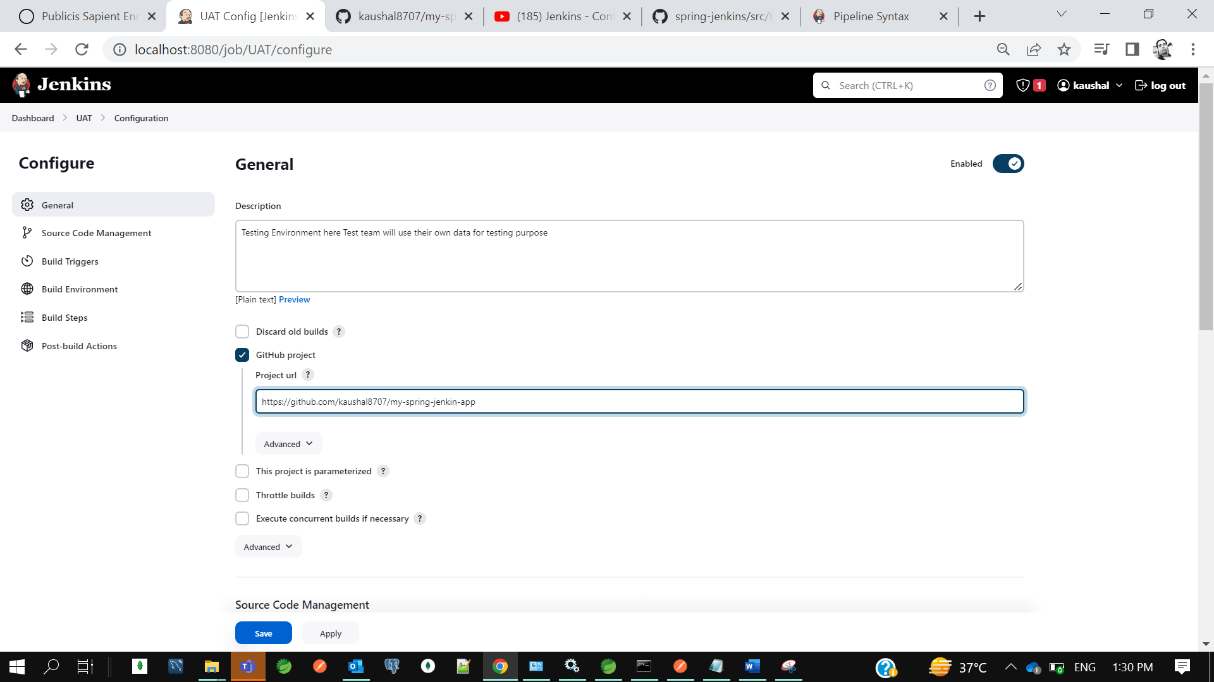

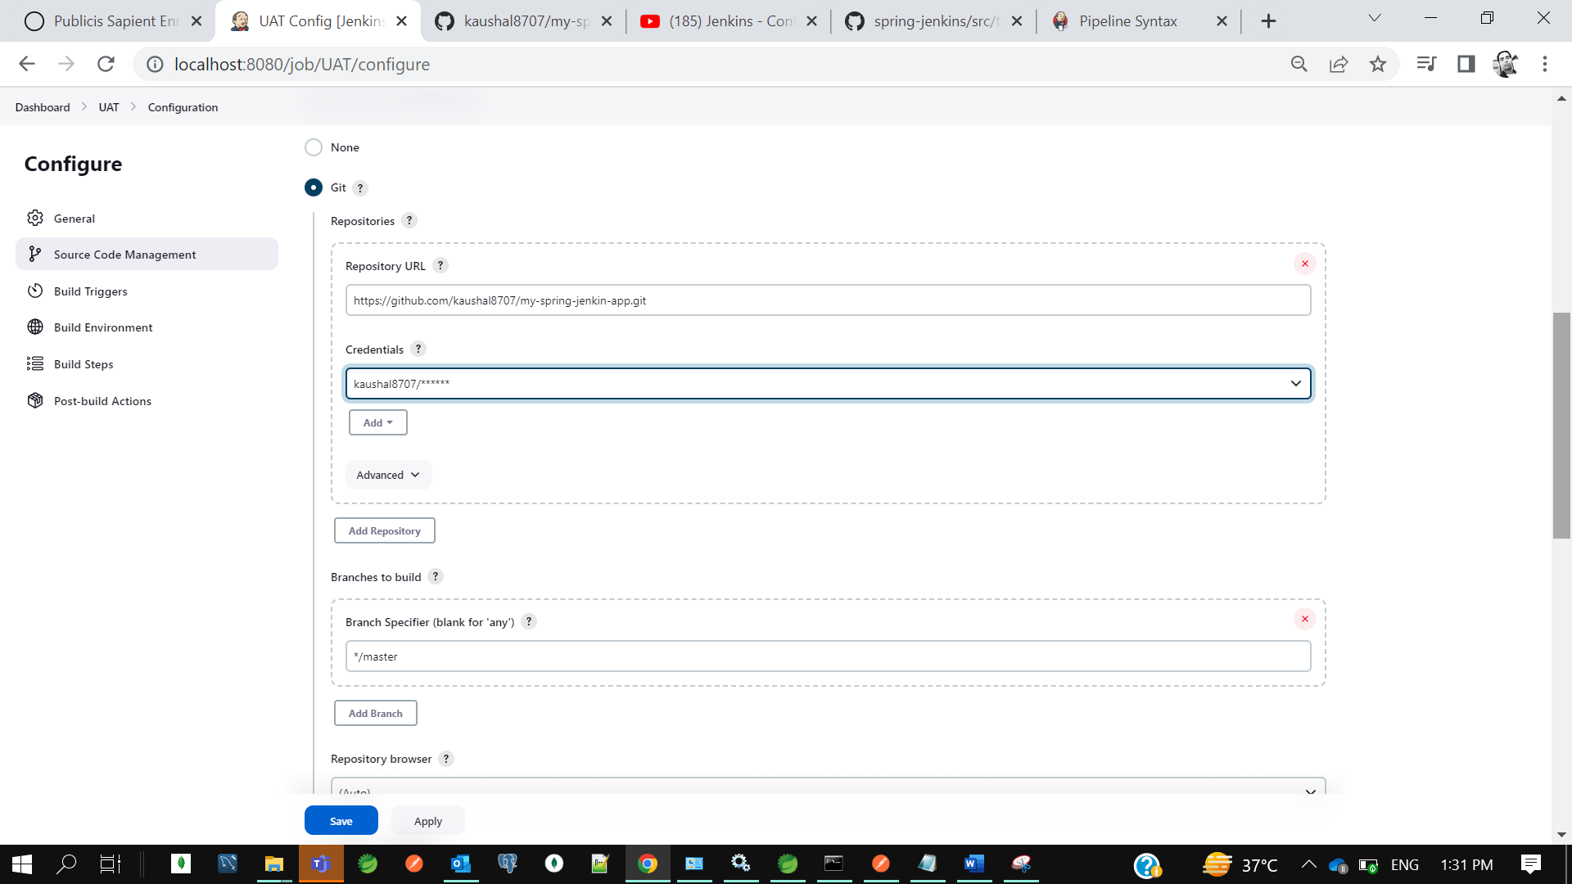

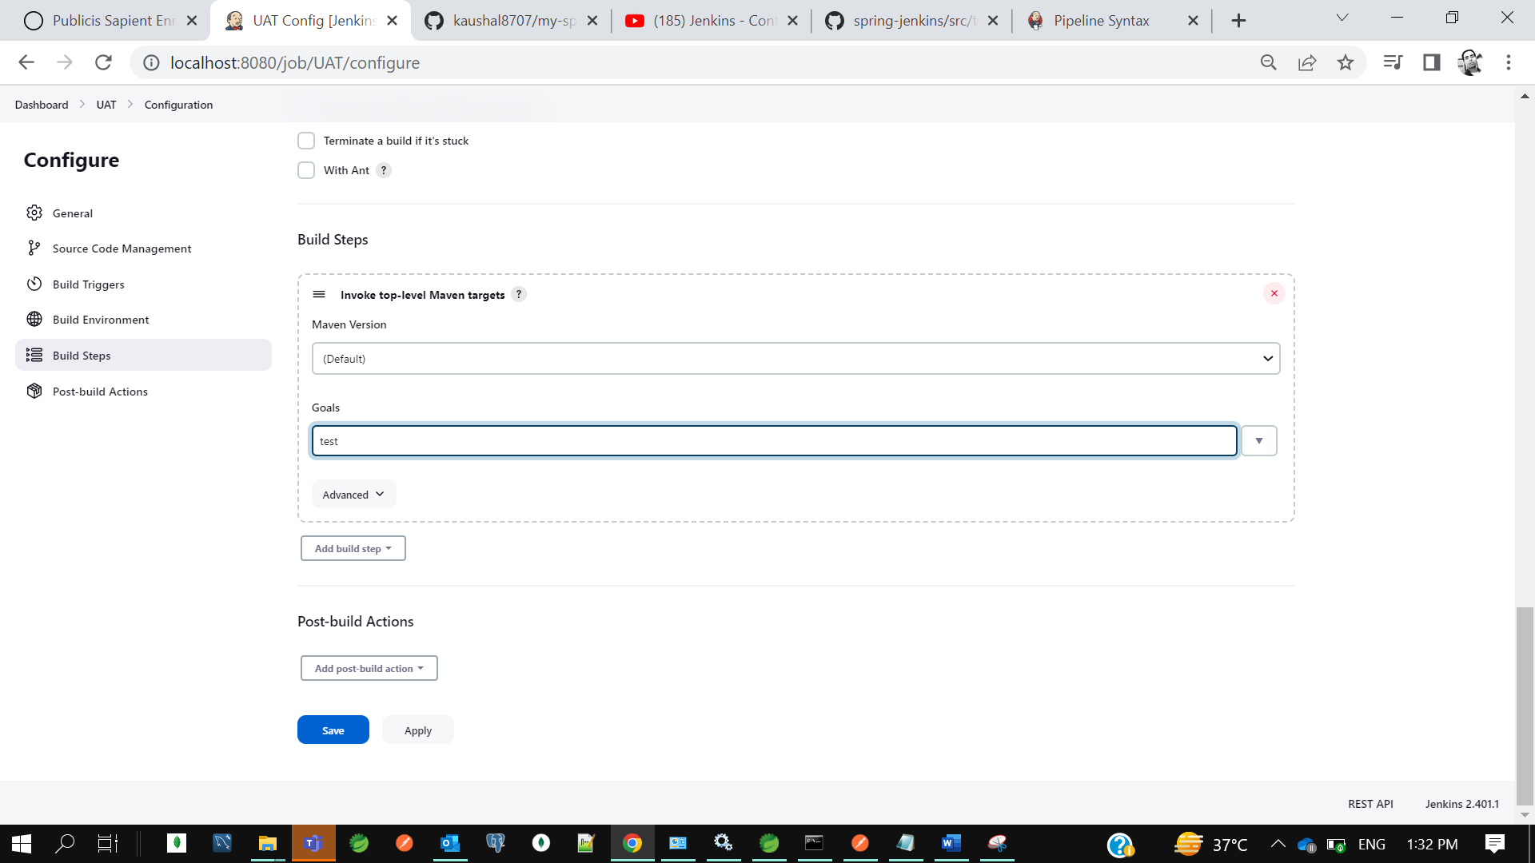

**Similarly create one more for production**

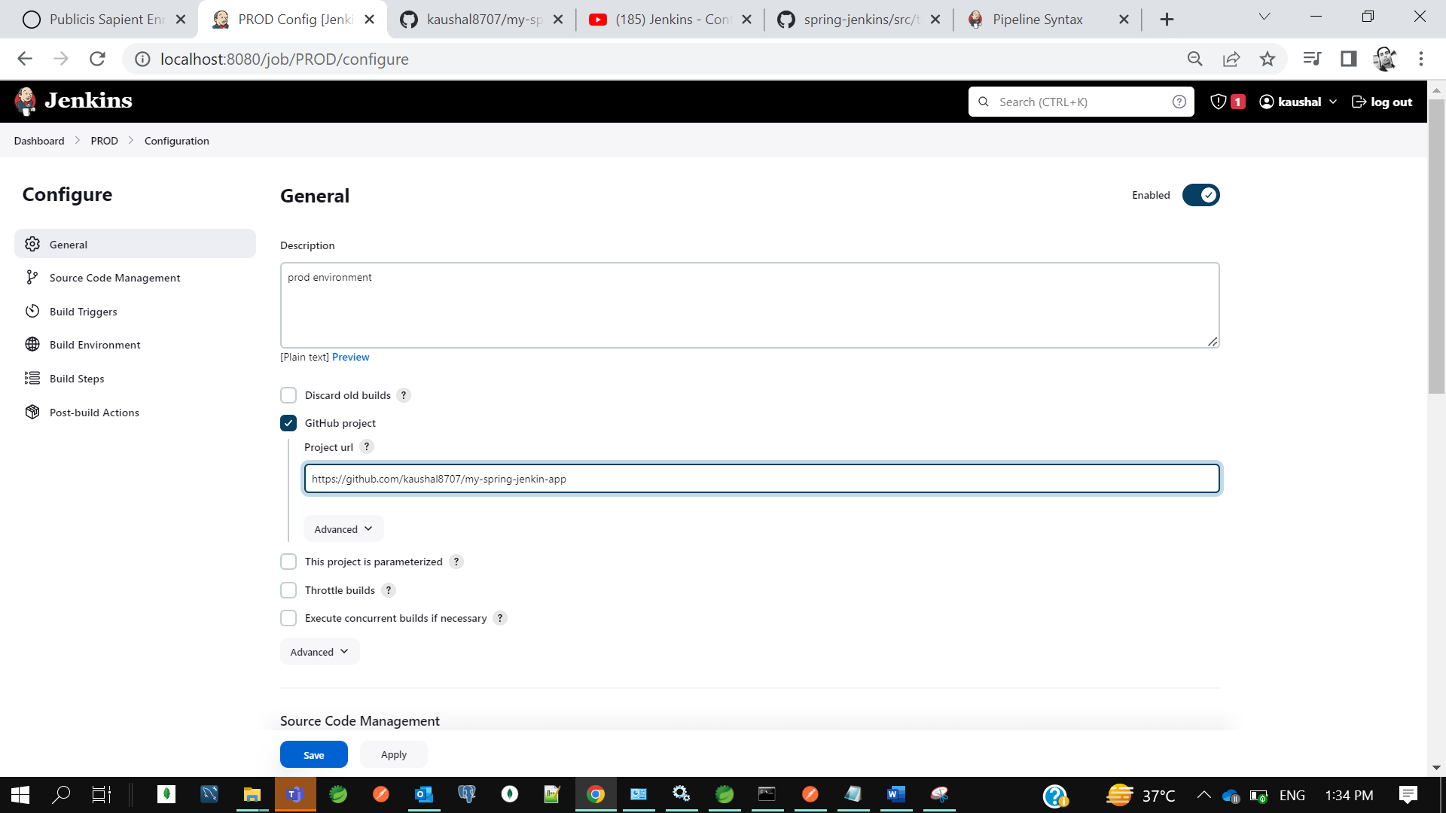

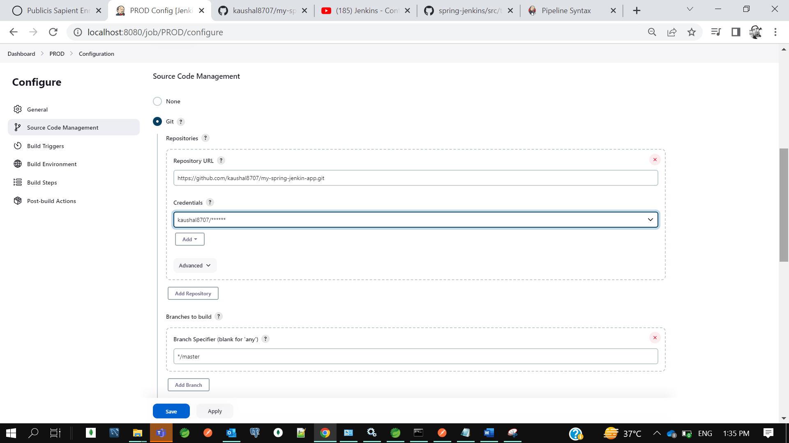

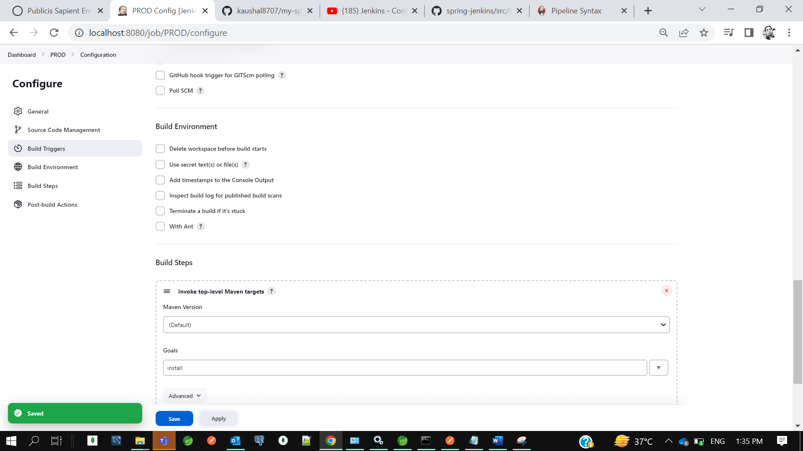

Now on dashboard u can see 3 jobs dev, uat and production.

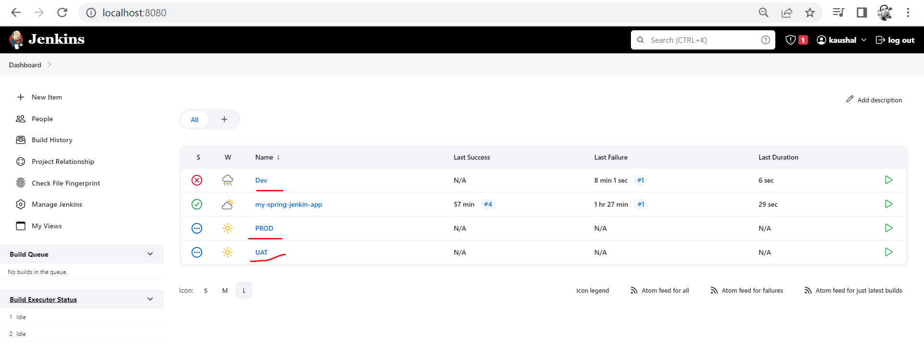

**Now let’s create a Pipeline with the help of Build Plugin Pipeline.**

Go to jenkins-> Manage jenkins -> plugins-> Available plugin

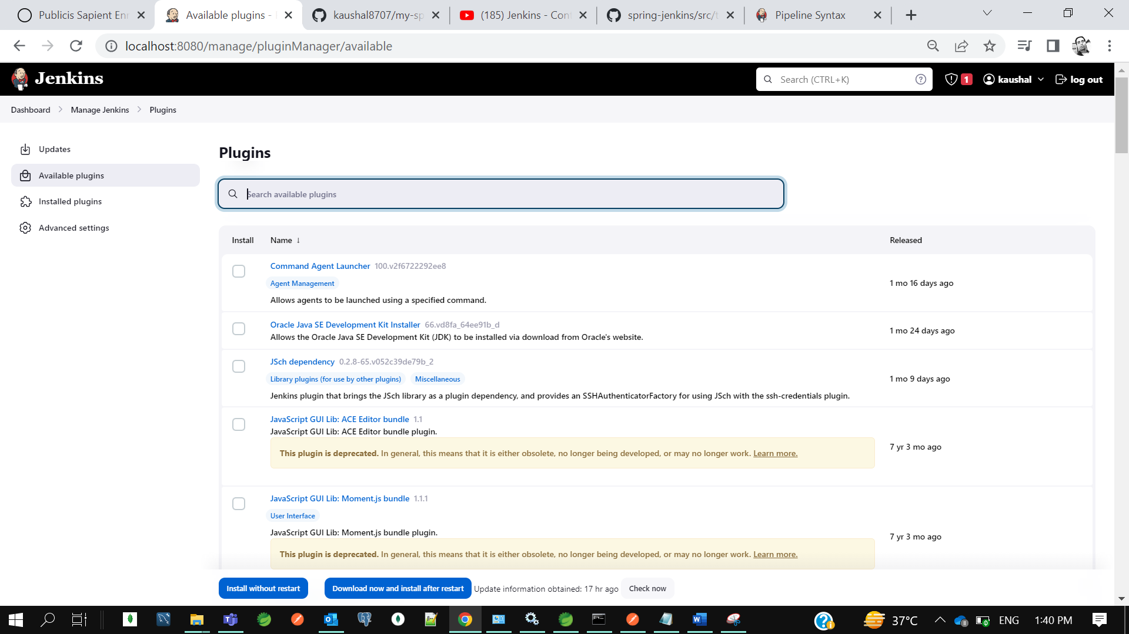

Type build pipeline

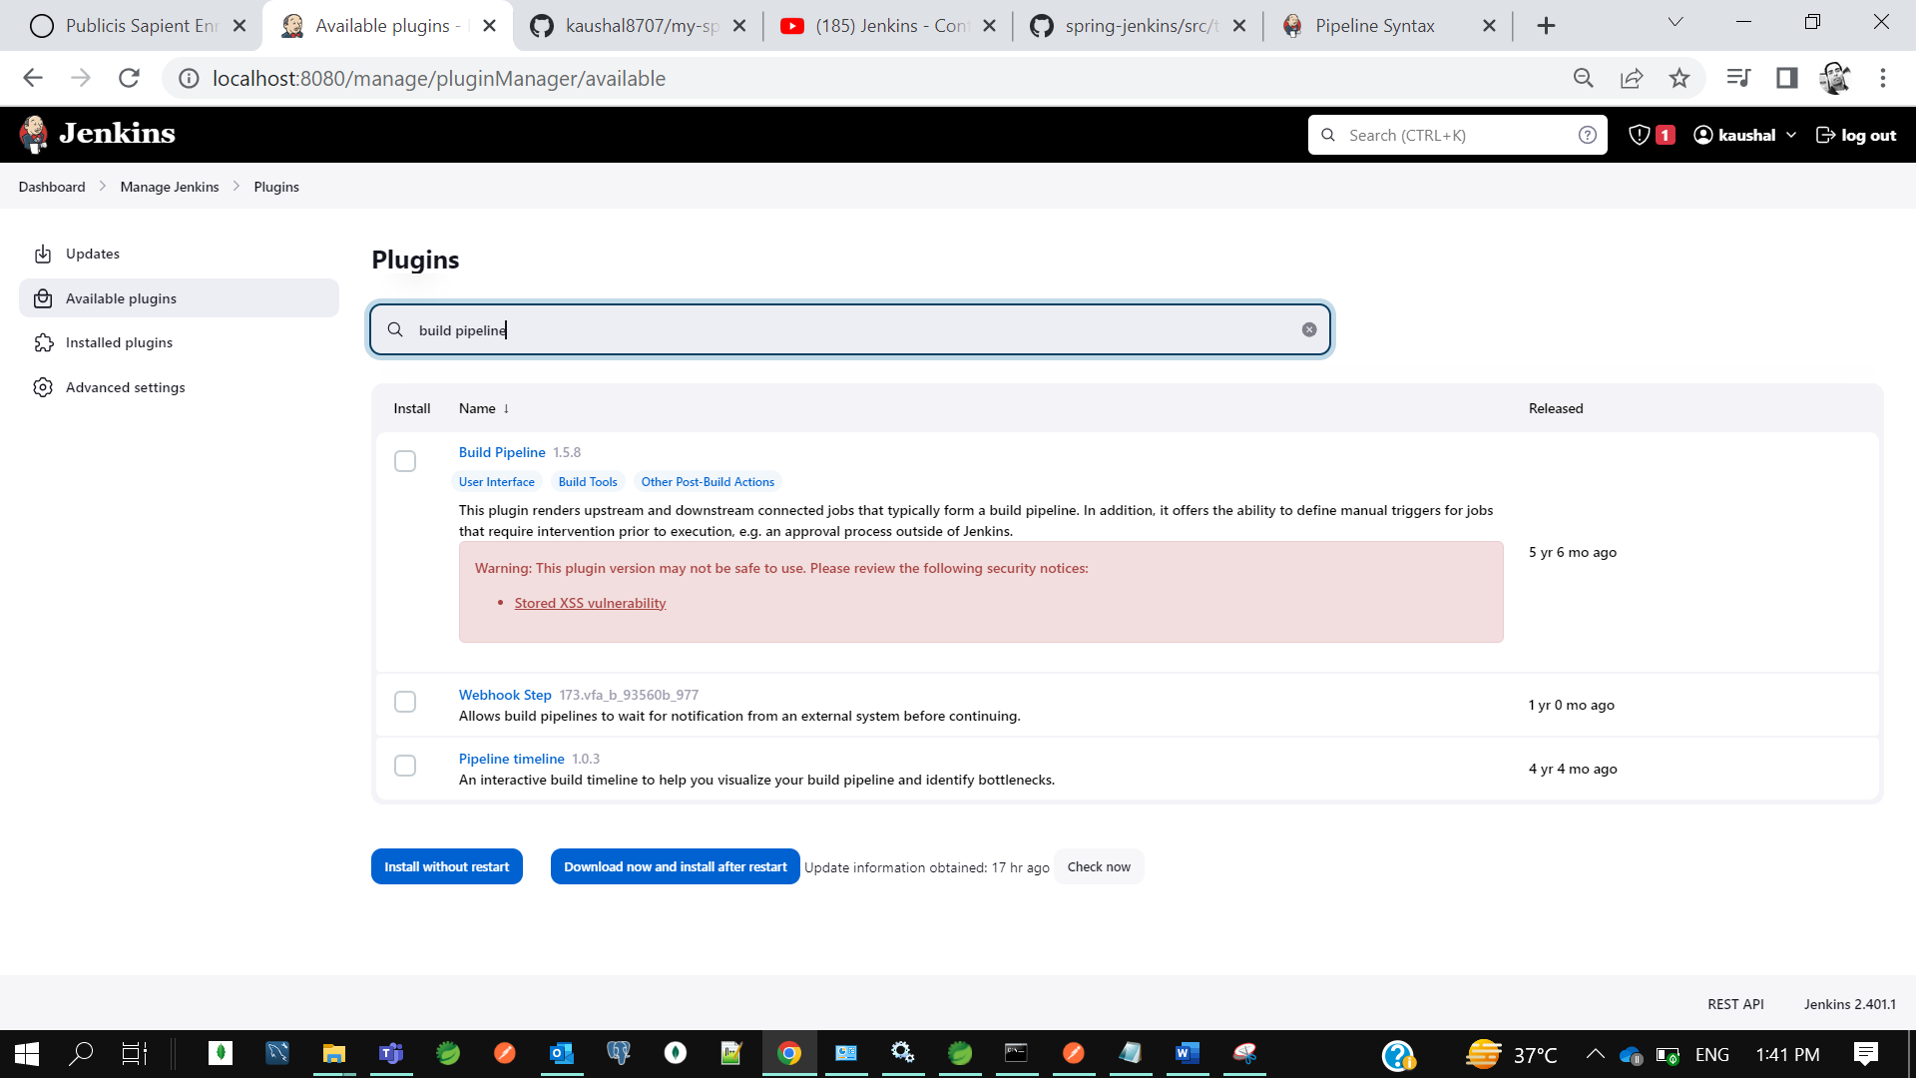

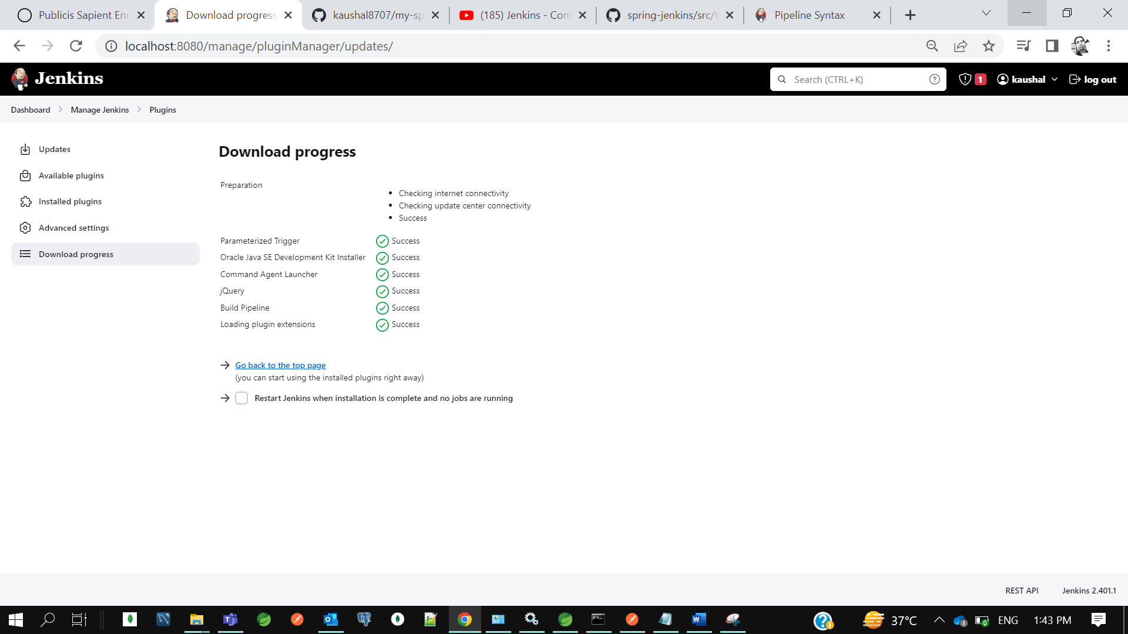

**Now go to jenkins dashboard and click on +**

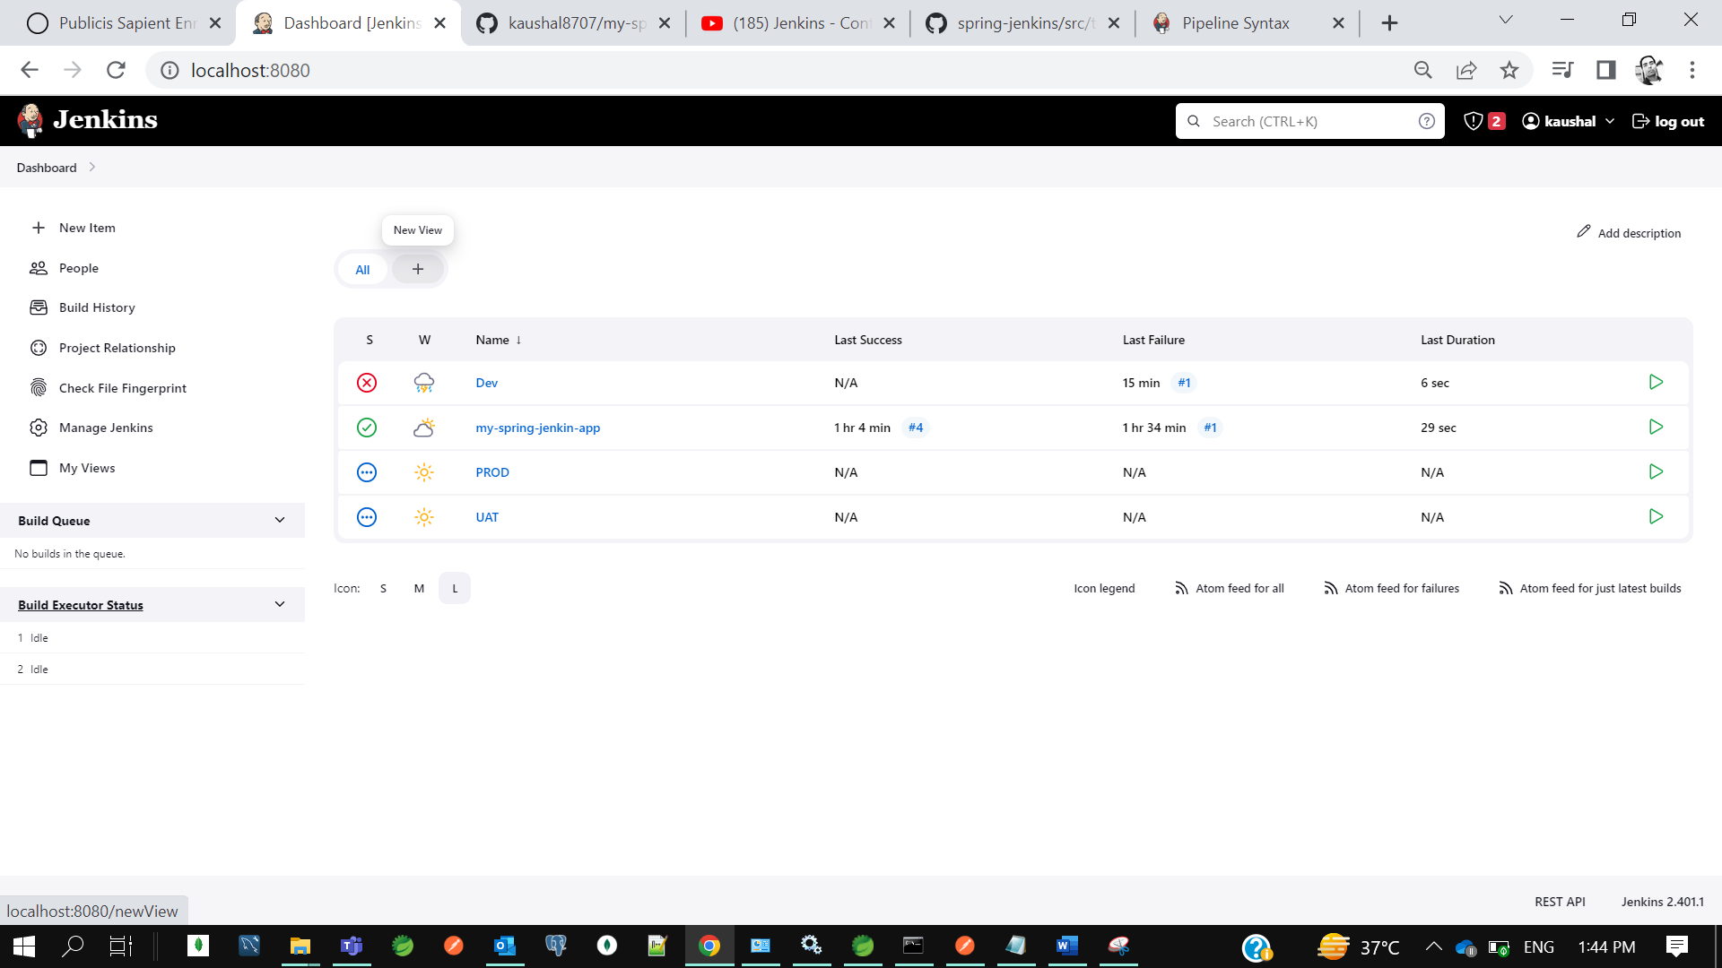

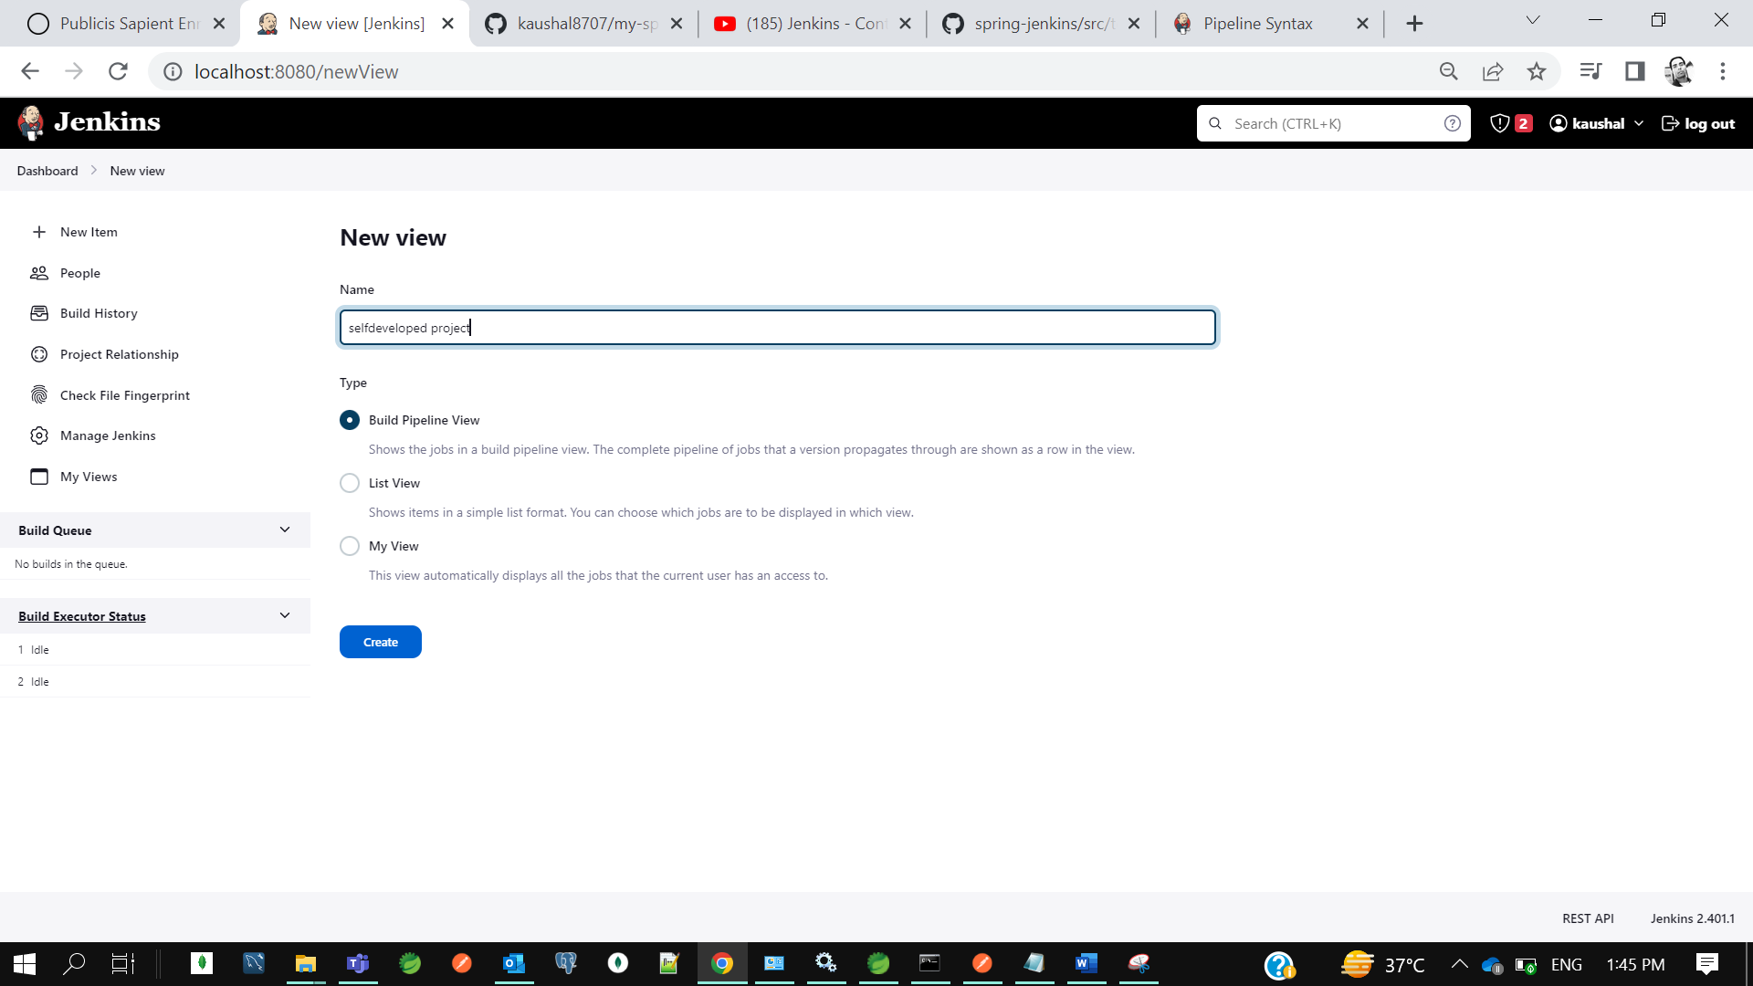

Initial job means once you commit your code which job you want to start first, I want dev.

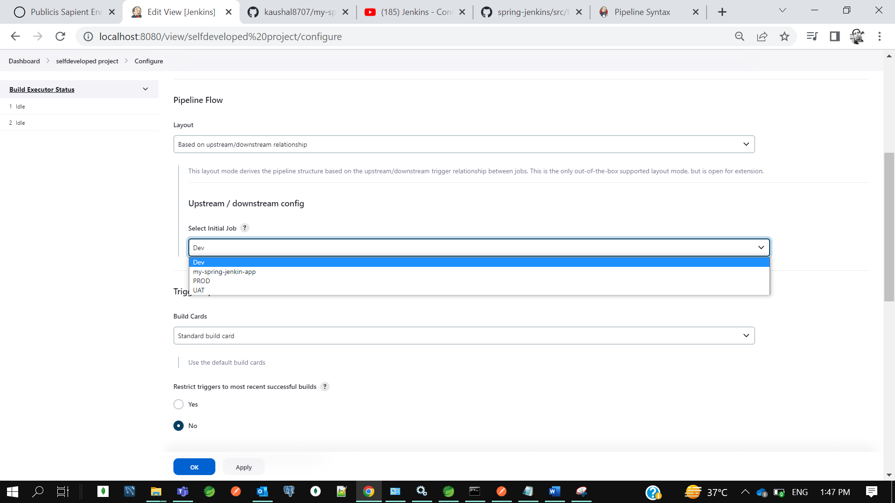

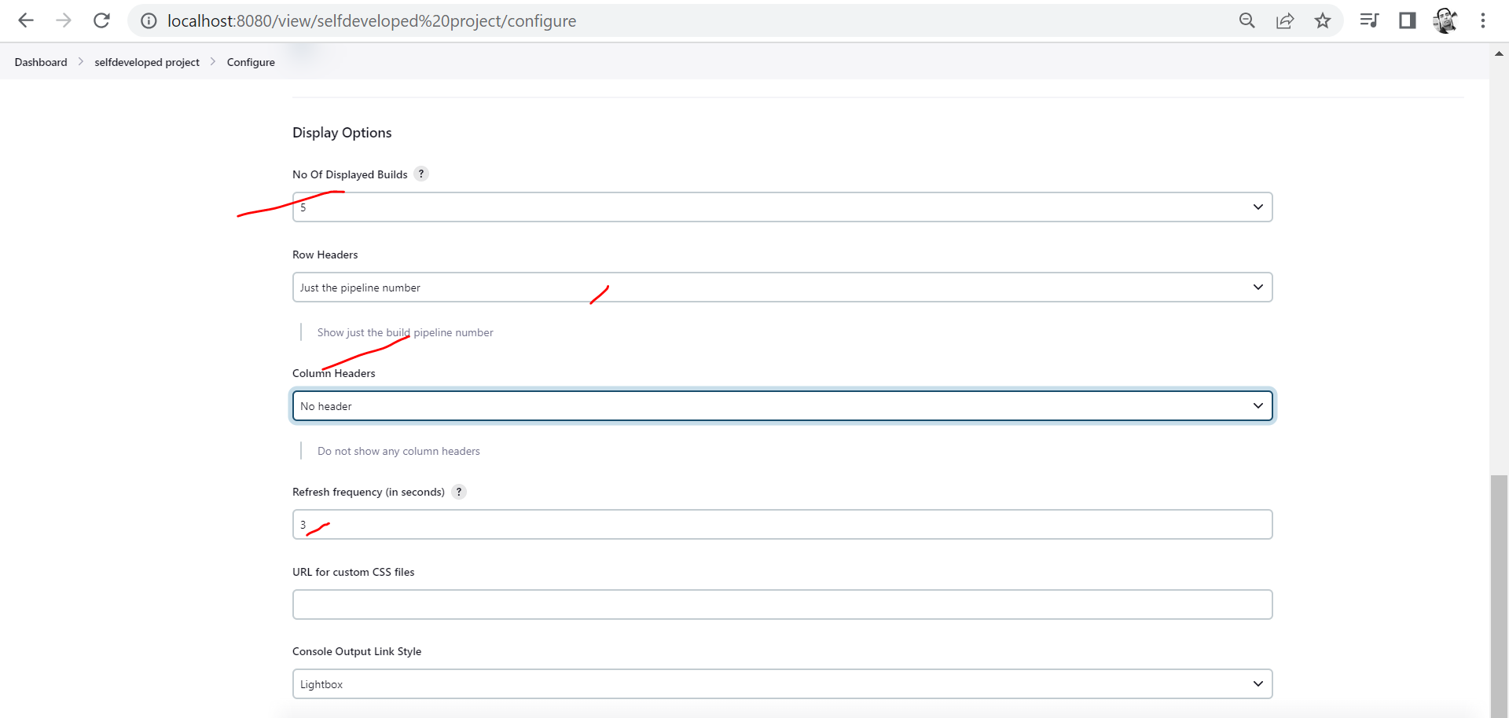

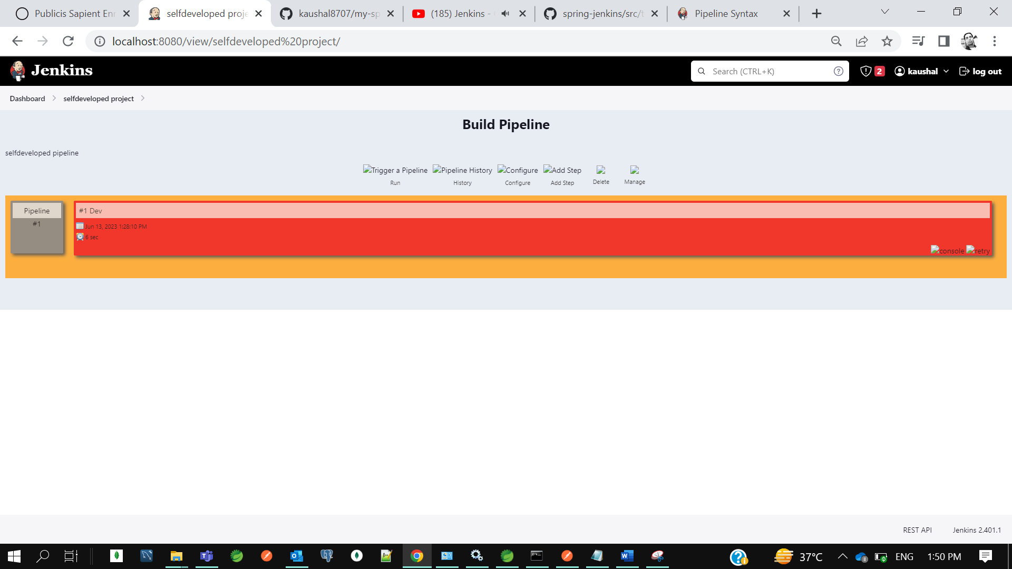

I want after my dev build completed; I want to run my uat build so go to jenkins dashboard then uat-> configure

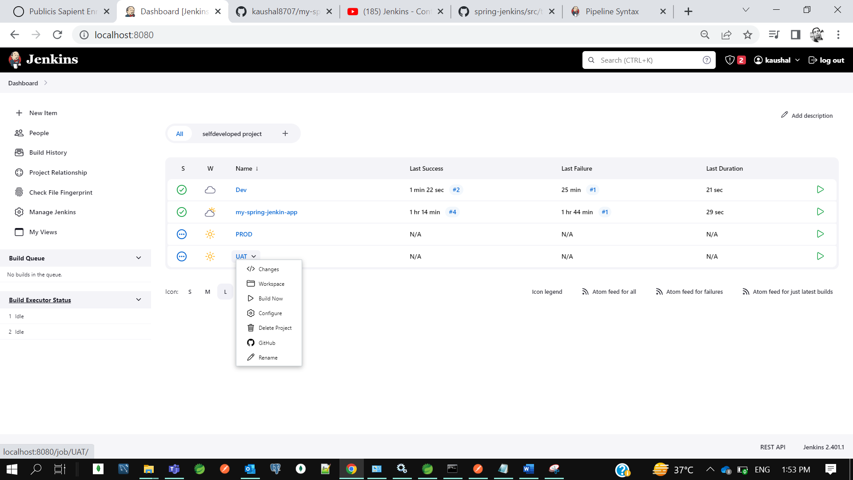

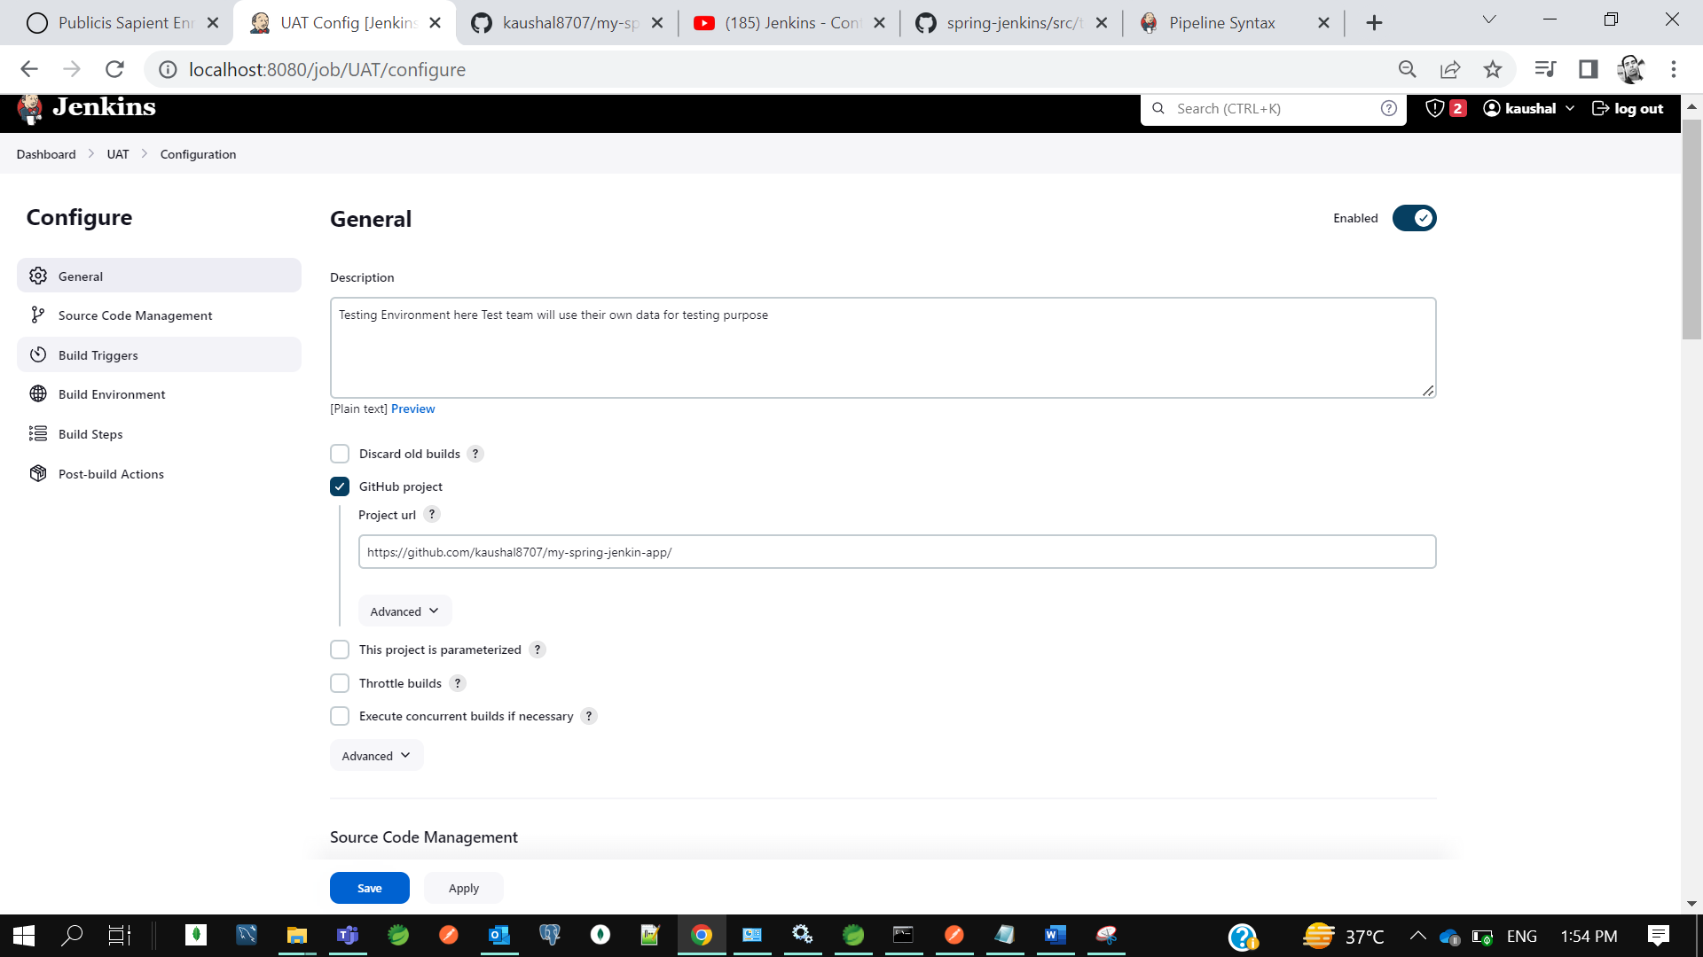

Then go to the build trigger section.

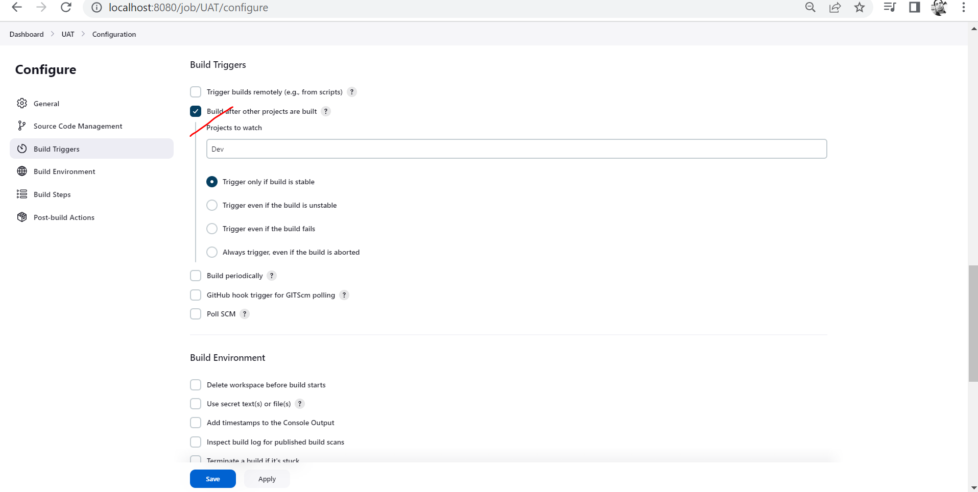

Then apply and save

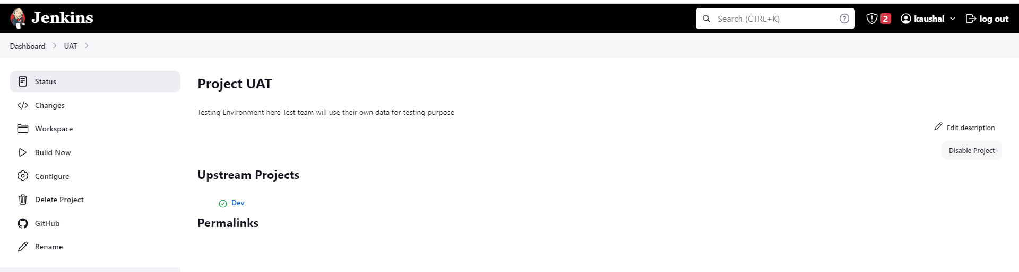

Once this uat will be done I want to run this production job.

Prod-> configure-> Build Trigger->Build after other project are build(UAT)

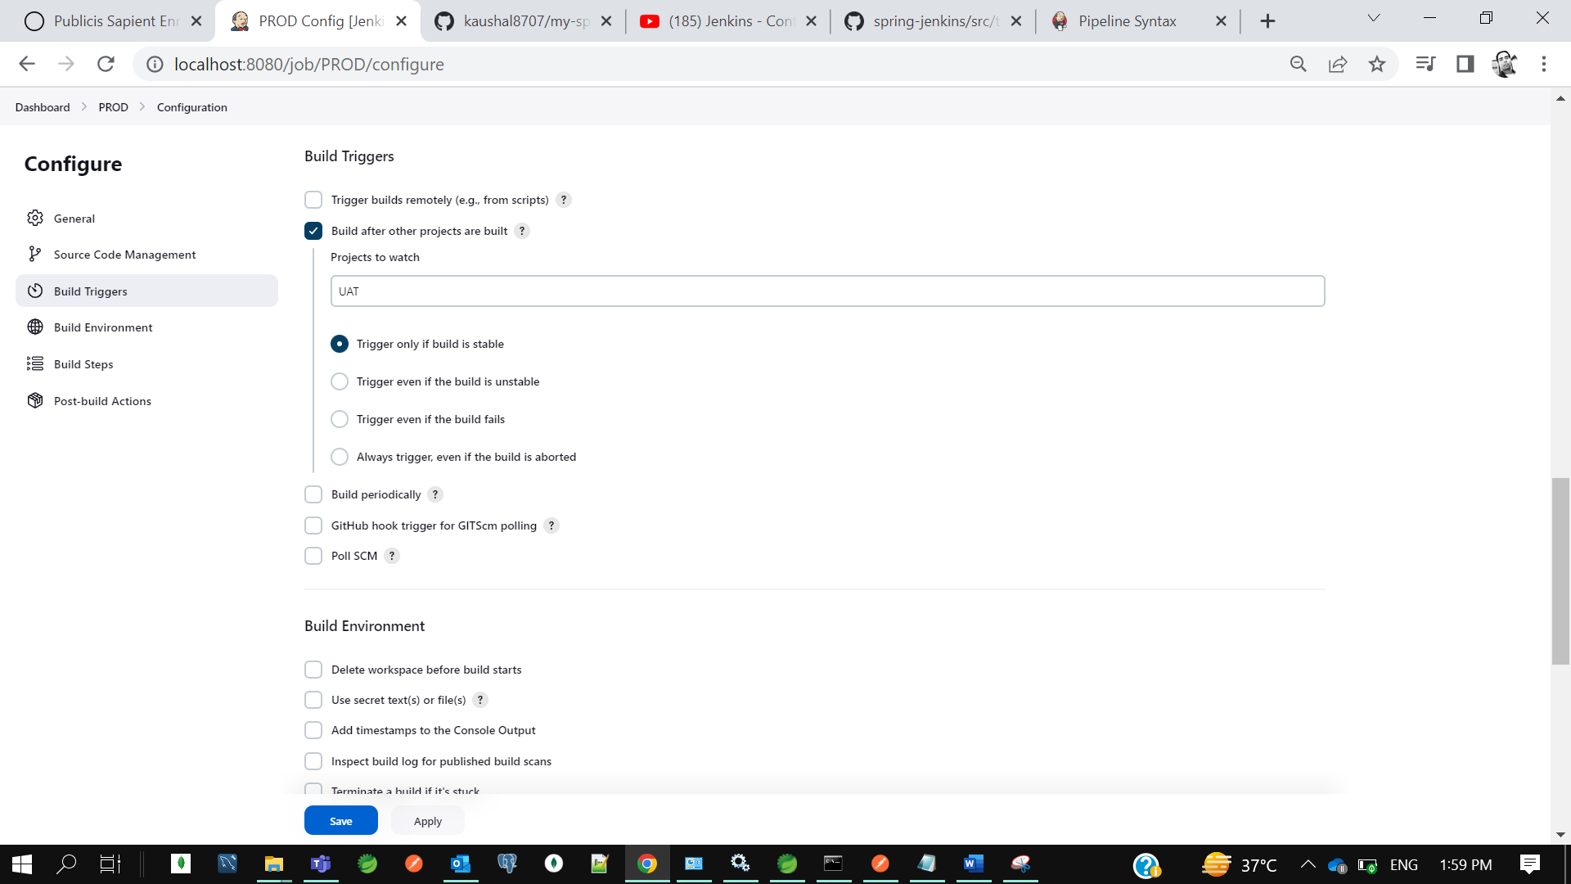

Go to jenkins dashboard and then click selfdeveloped project pipeline

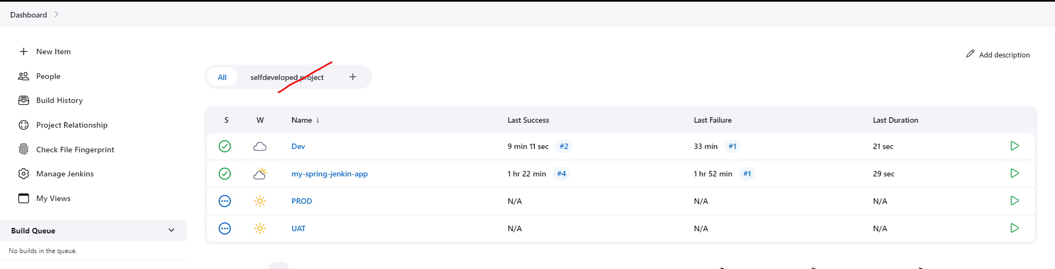

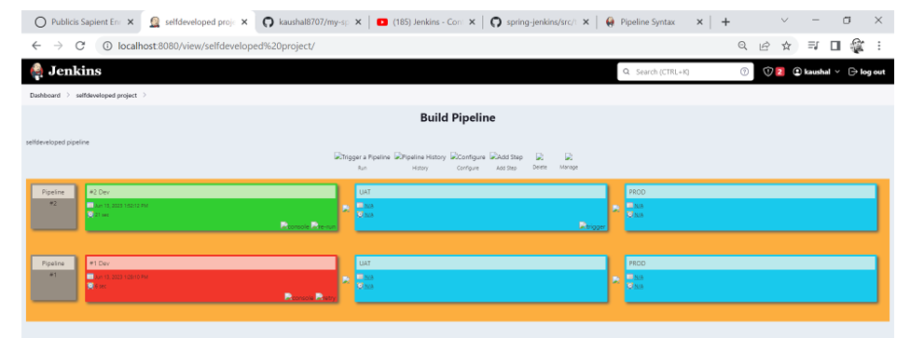

Let’s do some changes in code then we will give build to dev then we will see the pipeline workflow.

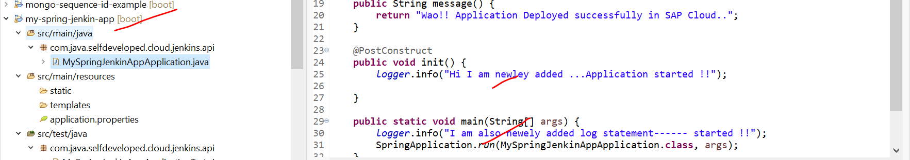

Now let’s commit to git

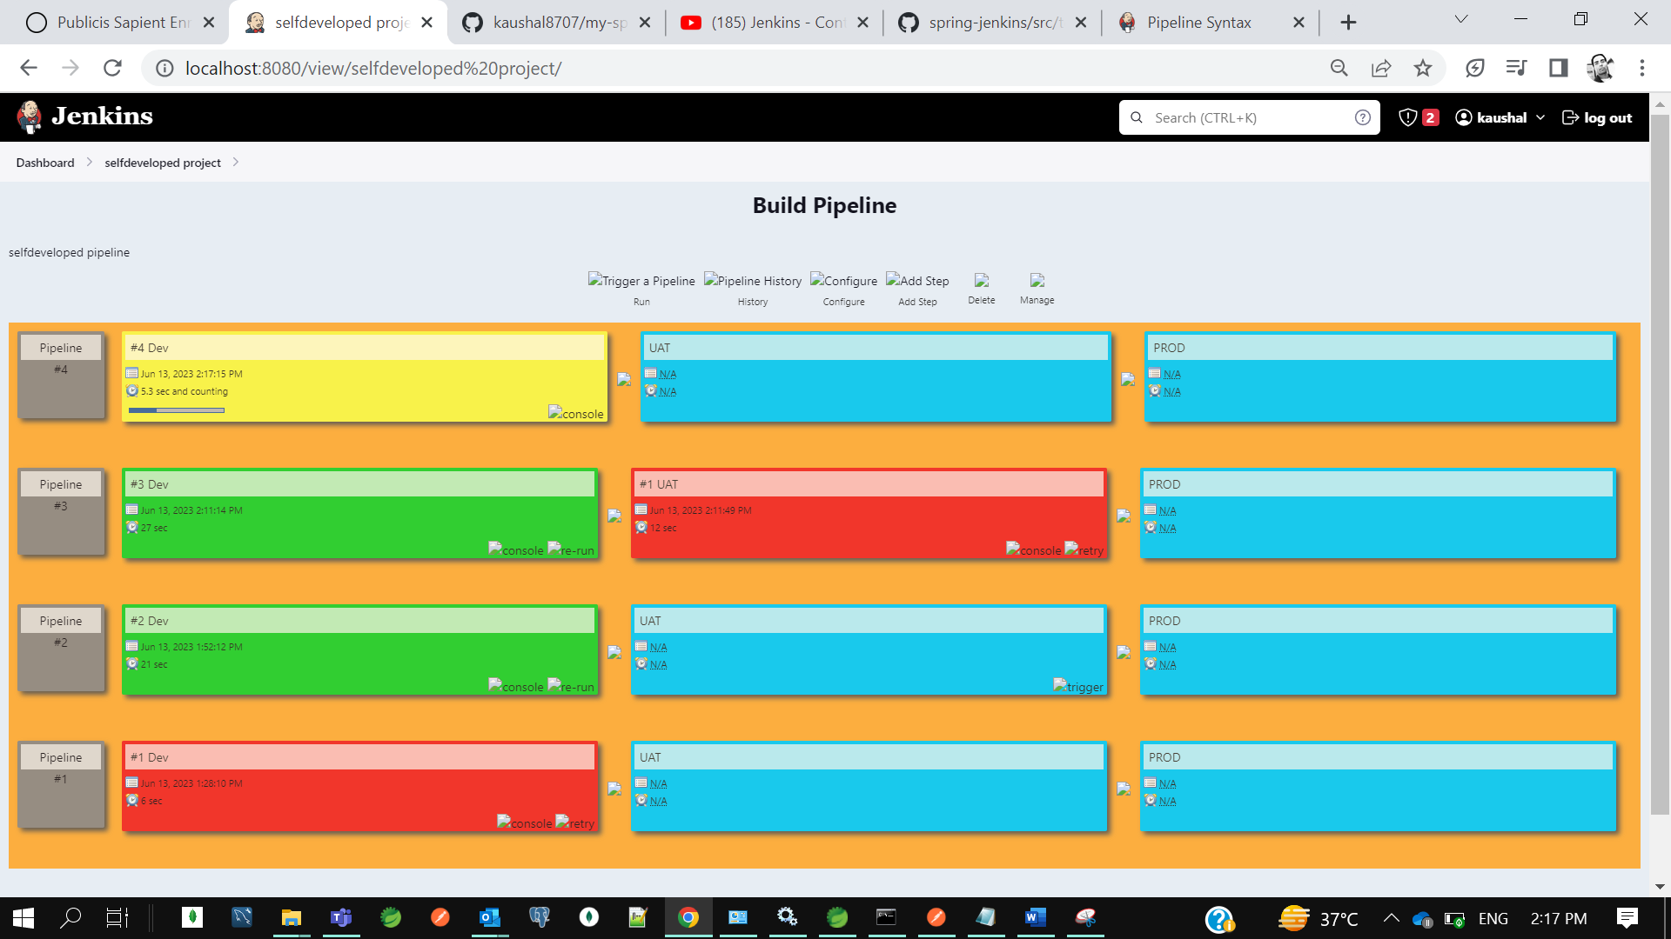

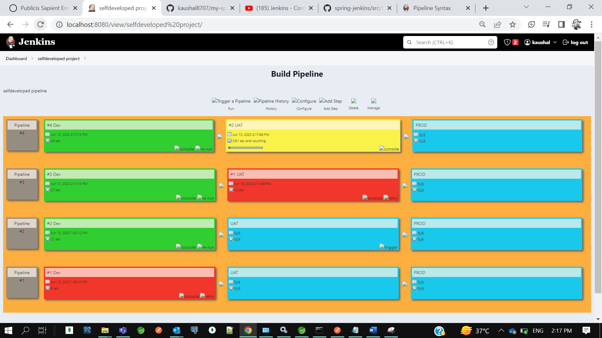

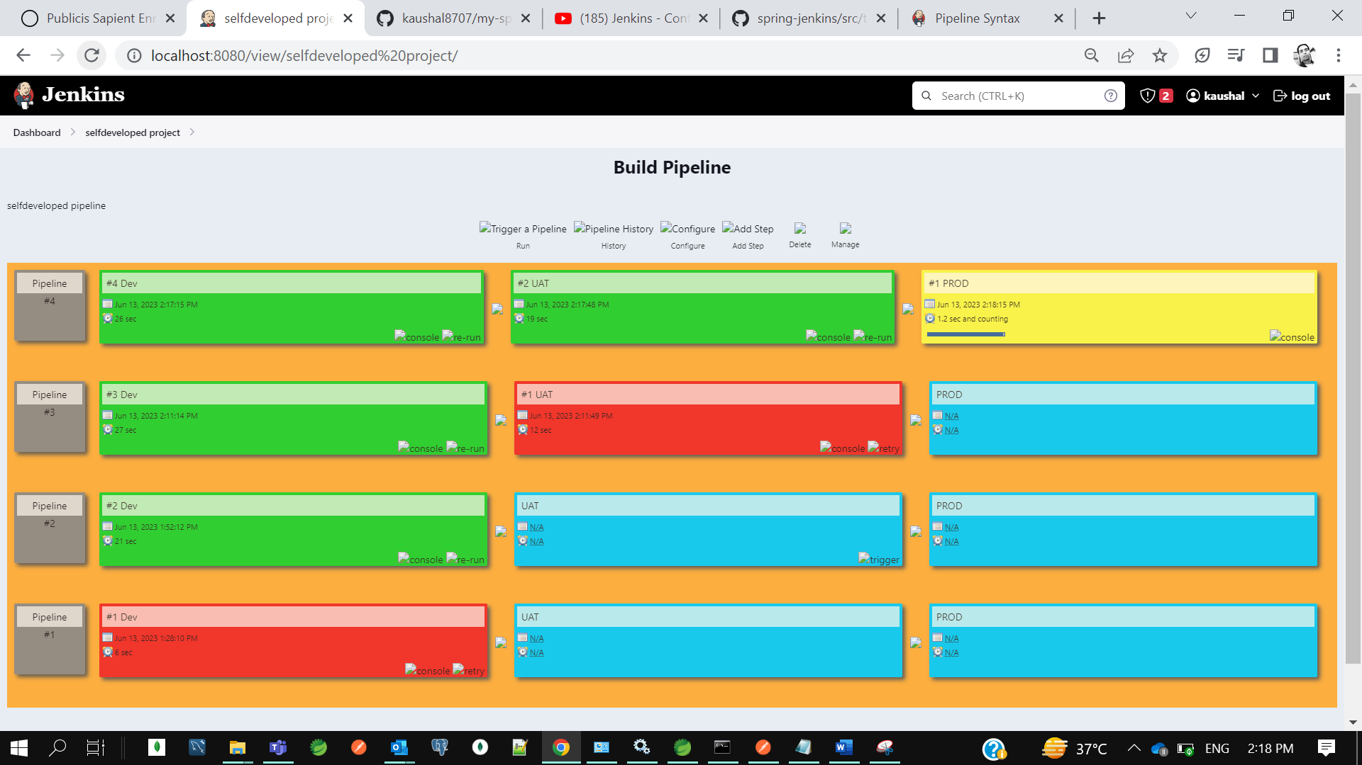

So, first Dev then UAT then prod build got started so this is the advantages of using the pipeline here like multiple job will be run in the single shots with an automated way no need to trigger manually like move ur code to dev and then uat and then prod this is the pipeline tool.

So if our first job is failed then our next job is not trigger like UAT or PROD.



So we can check the console output of dev.

for push and pull Docker Images In Docker Hub

---------------------------------------------

open cmd

>> docker

>> docker images

>> docker login (Enter uname(kaushal8707) & pwd for Docker Hub)

++ create a repository name in Docker Hub before pushing your images to docker hub ( Repo : selfdeveloped)

++ Tag your docker image to docker repository before pushing

>> docker tag spring-boot-dockerize.jar:latest kaushal8707/selfdeveloped:spring-boot-dockerize.jar

++ push docker image to Docker Hub

>>docker push kaushal8707/selfdeveloped:spring-boot-dockerize.jar

++ pull Docker Image from Docker Hub

>> docker pull kaushal8707/selfdeveloped:spring-boot-dockerize.jar

check the list of images

>> docker image ls

run docker image as a docker container

>> docker run -p 9090:8080 spring-docer-mayyapp.jar ( where myapp.jar is our application jar 9090 out of container to access app and 8080 we have mentioned to expose in docker file)

after deploy hit the rest endpoint url to access application rest API

create a docker images withdocker file commands

---------------------------------------------------

>> docker build -t spring-docer-mayyapp.jar .

>> docker image ls

>> docker run -p 9090:8080 spring-docer-mayyapp.jar

create a docker images without docker file commands

---------------------------------------------------

spring In built provides the cloud native buildpacks after 2.3.1 RELEASE version

++ to create a docker image

>> mvn spring-boot:build-image

>> docker images

>> docker run -p 8081:8081 spring-docer-mayyapp.jar